AZ-104 Project

DESCRIPTION

**Business Scenario**

OSS Corporation is a globally distributed firm. They have their headquarters in **East US** with another branch office in **SouthEast Asia**. Currently, they are working on a project and decided that the application tier of this project will reside in one of its branch regions. For security reasons, OSS Corporation management is adamant on keeping their data tier in the headquarter region.

As an organization, they are open to suggestions and are currently evaluating Azure as a deployment platform. To prepare for the deployment of IaaS **Standard DS1 v2**, OSS Corporation must deploy an IaaS v2 virtual network in the headquarter region for its database. But for the application, it should create another IaaS v2 virtual network in the branch region. In addition, because the communication between App and data should happen over a private channel, one needs to prepare their branch office virtual network for establishing connectivity to the headquarter’s IaaS v2 virtual network by creating a virtual network gateway and deploy a test IaaS **Standard DS1 v2** VM to the virtual networks for verifying the connection.

After the deployment team ensures the connectivity between both the networks, you can validate the same using Ping.

**Overview**

The major activities for this exercise are as follows:

1. Create virtual networks in the aforementioned region
2. Create test virtual machines in both the virtual networks
3. Establish the connectivity between both the networks via VNet peering
4. Ensure connectivity is established properly

headquarters in **East US**

branch office in **SouthEast Asia**.

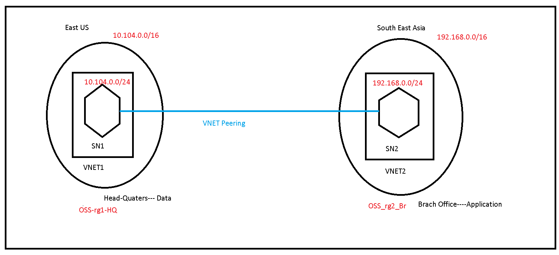

1. Step1: Create virtual networks in the aforementioned region

Step A: Create First Virtual Network in HeadQuaters (East US) Region

CIDR VNET: 10.104.0.0/16

CIDR Subnet: 10.104.0.0/24

Resource Group Name: OSS_rg1_HQ

VNET Name: VNET1

Subnet Name: SN1

Location: East US

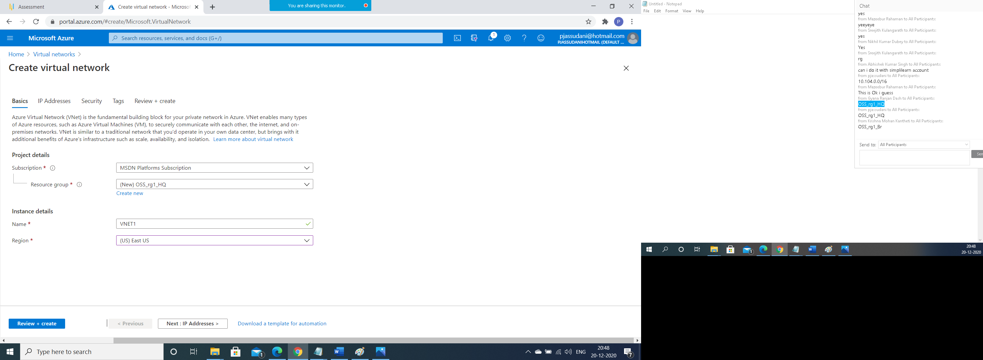

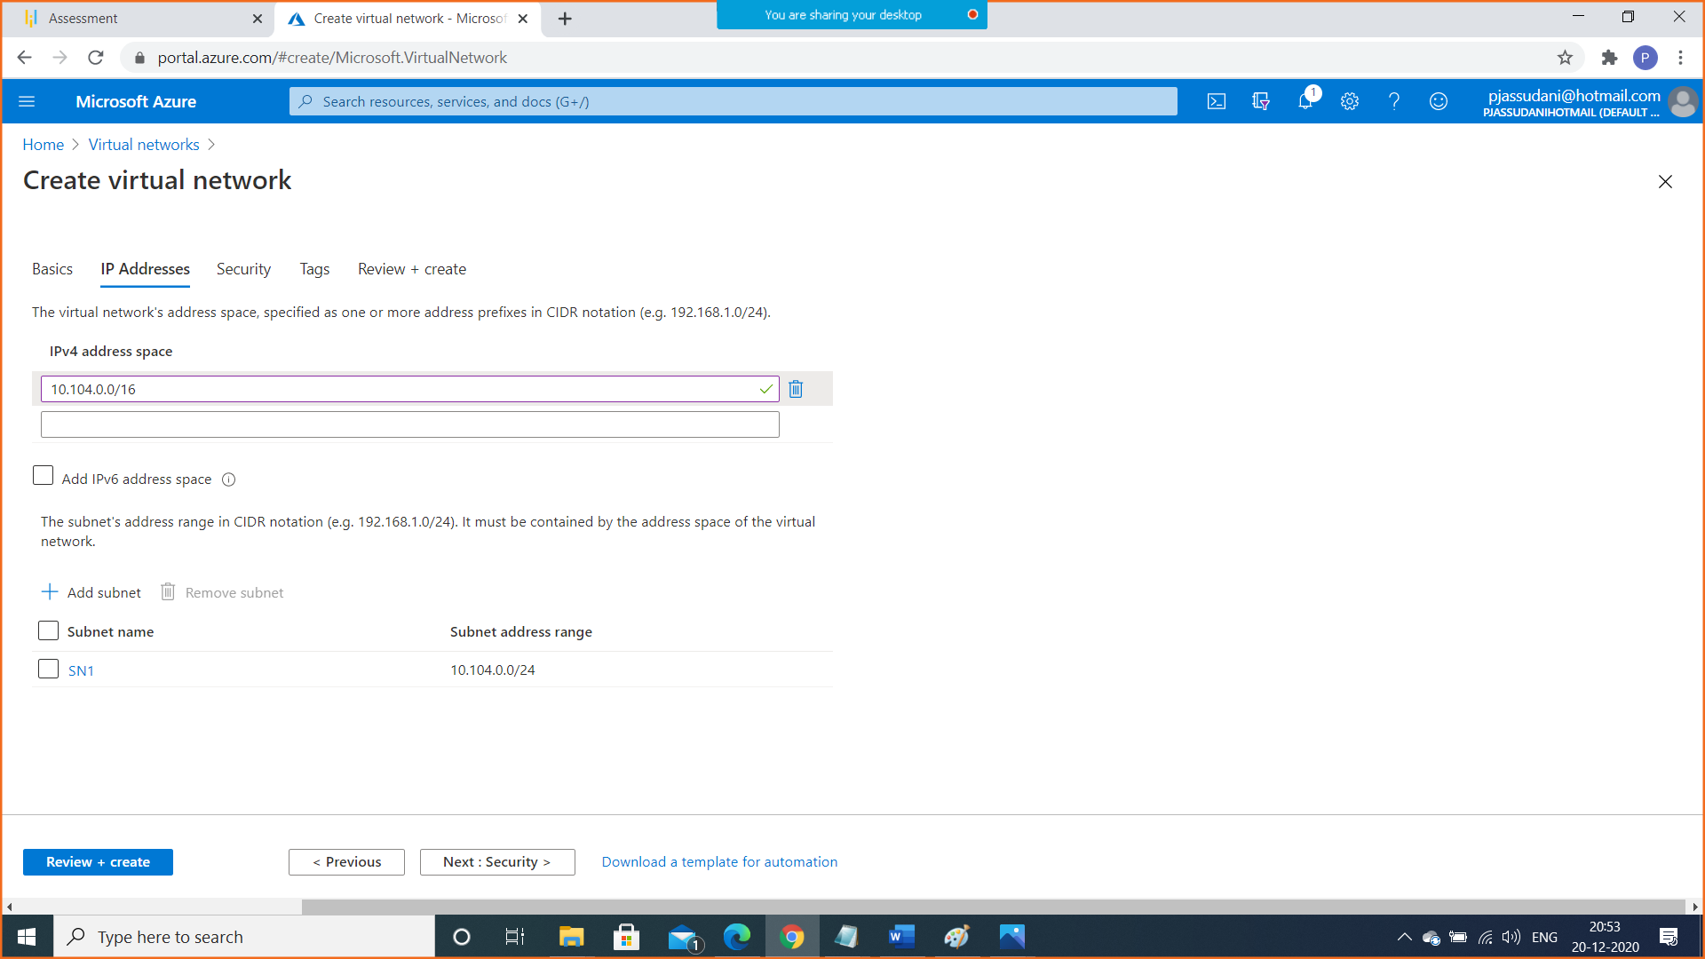

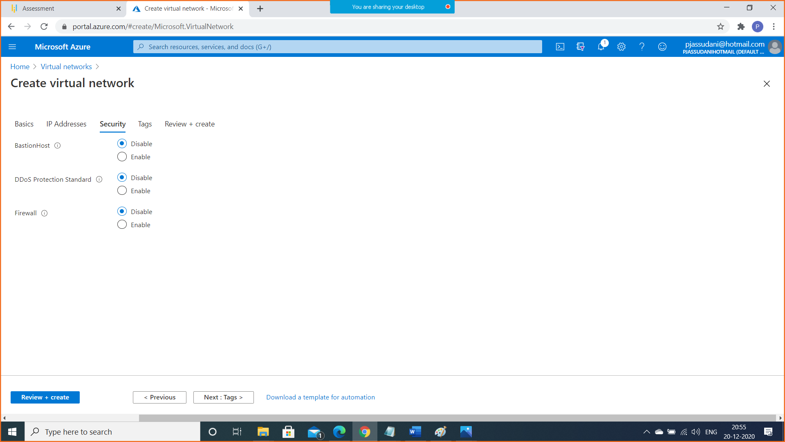

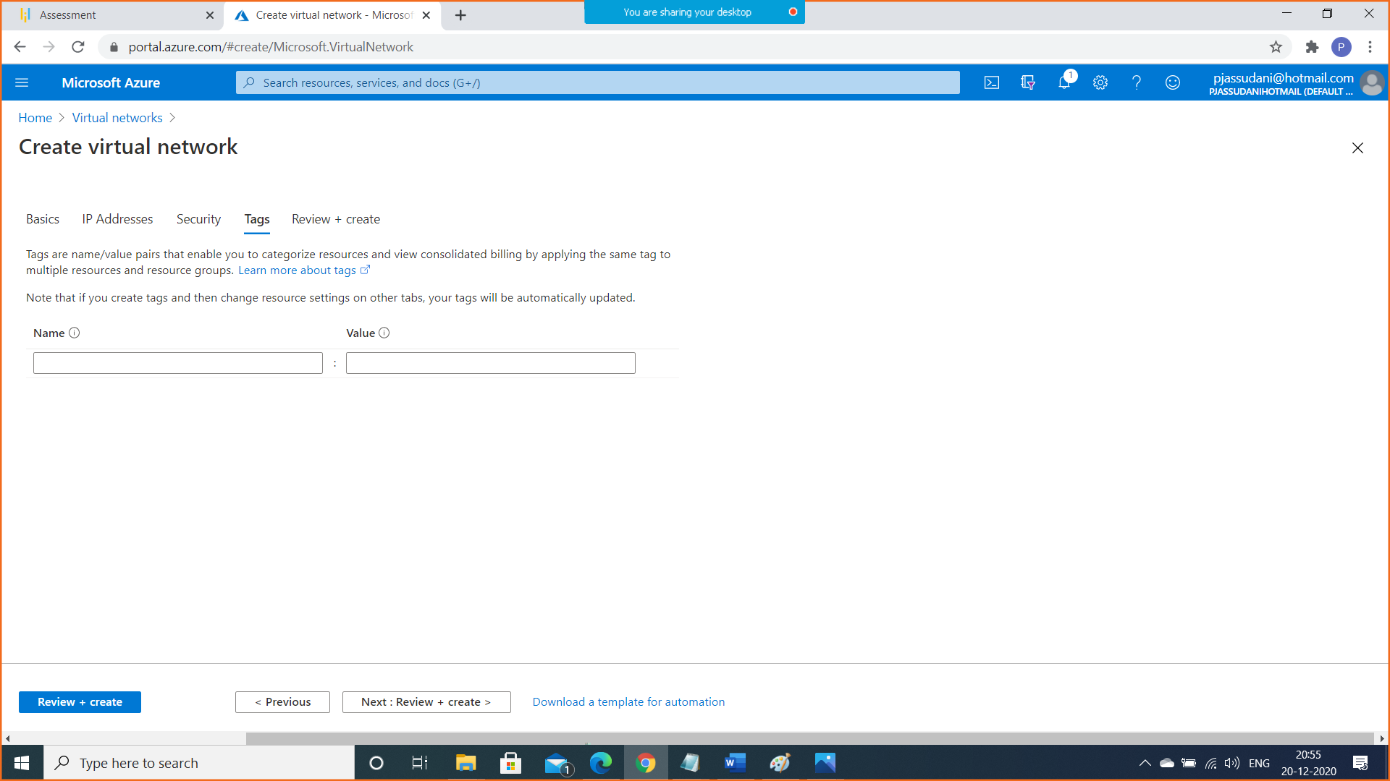

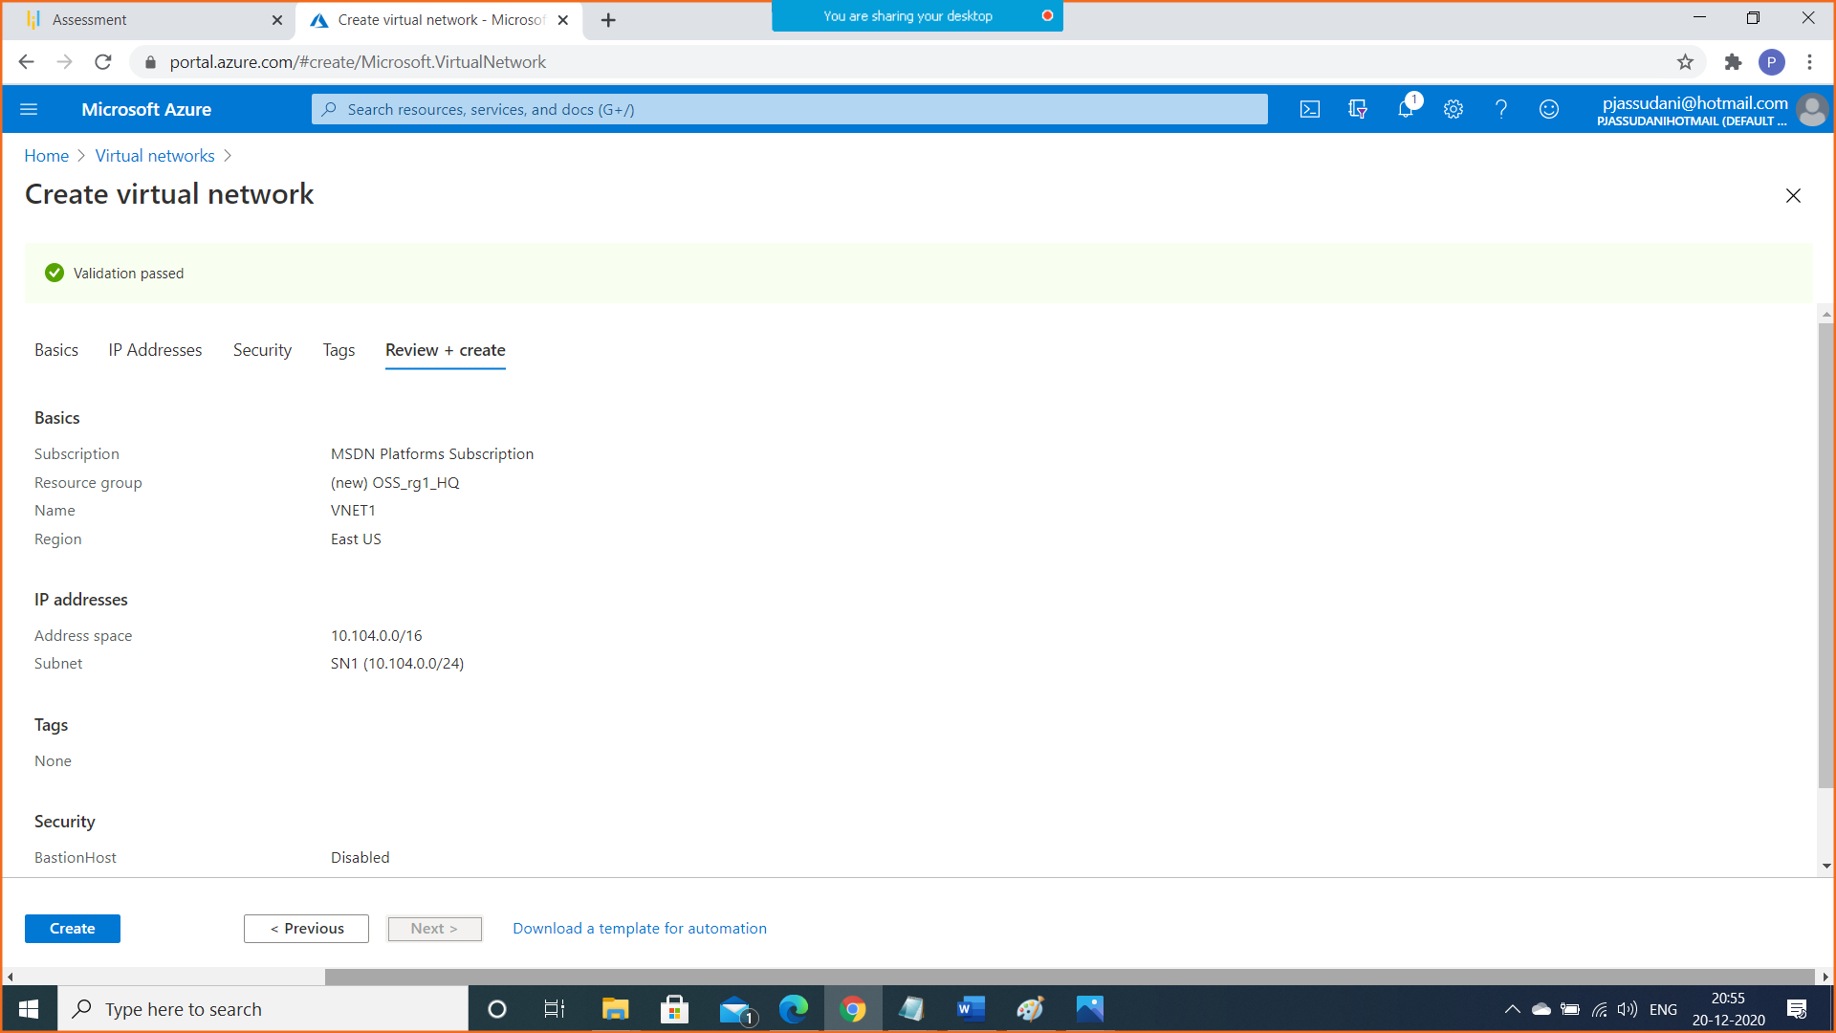

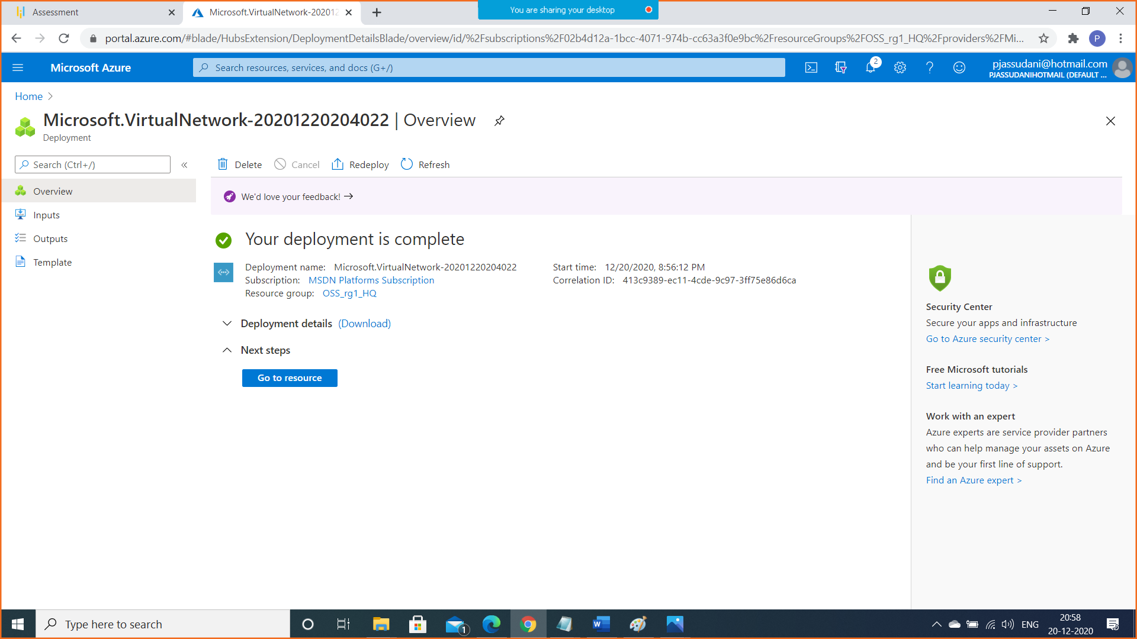

Virtual Network with Subnet is created in HeadQuaters (East US) Region.

Step B: Create Second Virtual Network in Branch Office (South East Asia) Region

CIDR VNET: 192.168.0.0/16

CIDR Subnet: 192.168.0.0/24

Resource Group Name: OSS_rg2_Br

VNET Name: VNET2

Subnet Name: SN2

Location: South East Asia

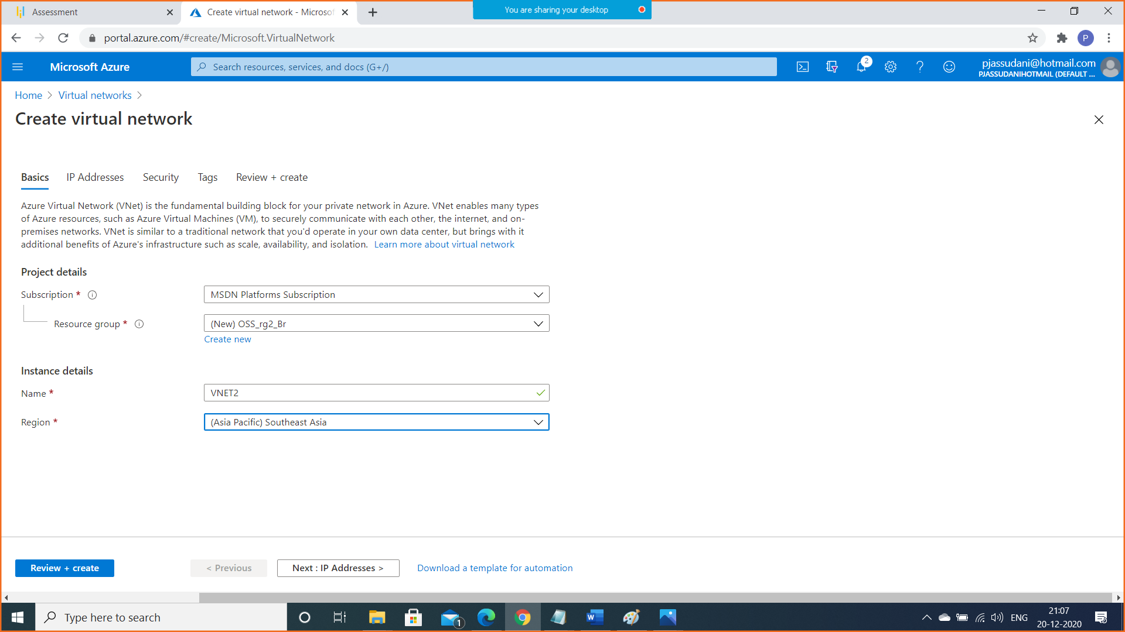

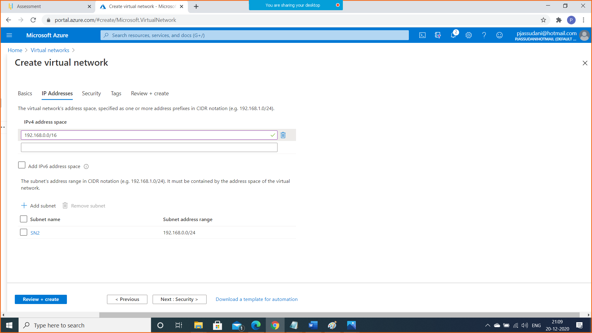

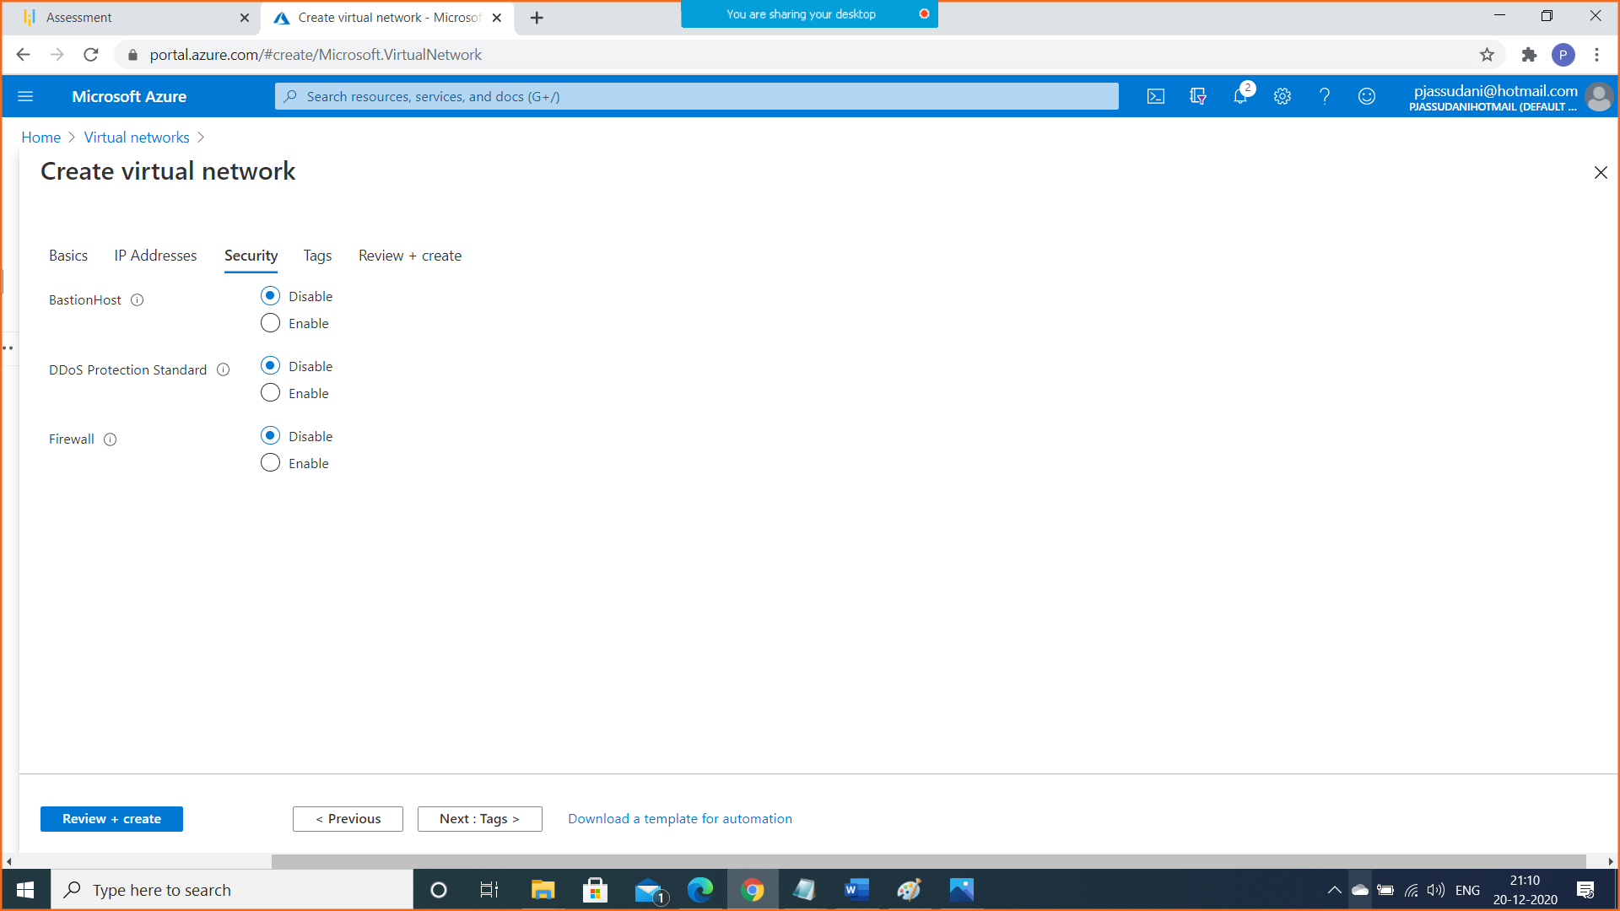

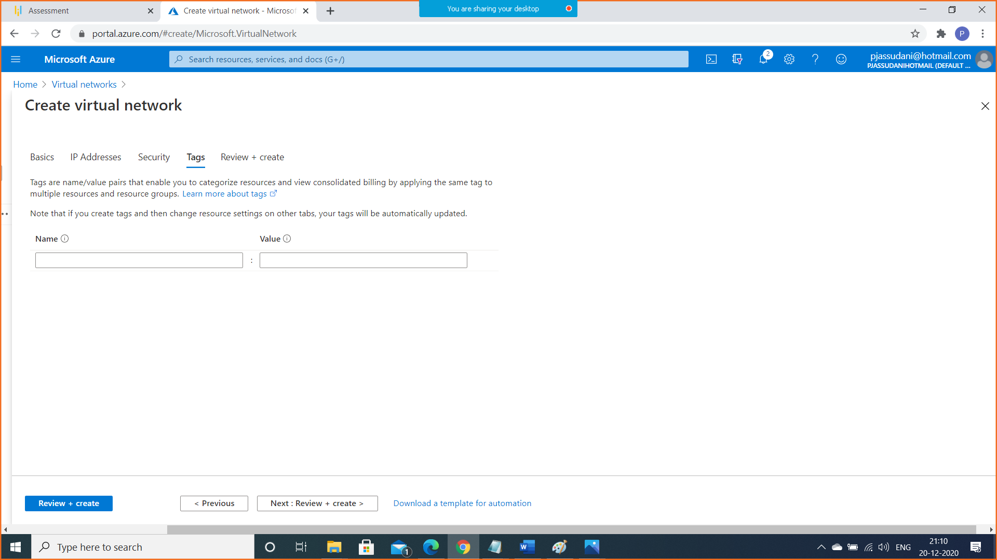

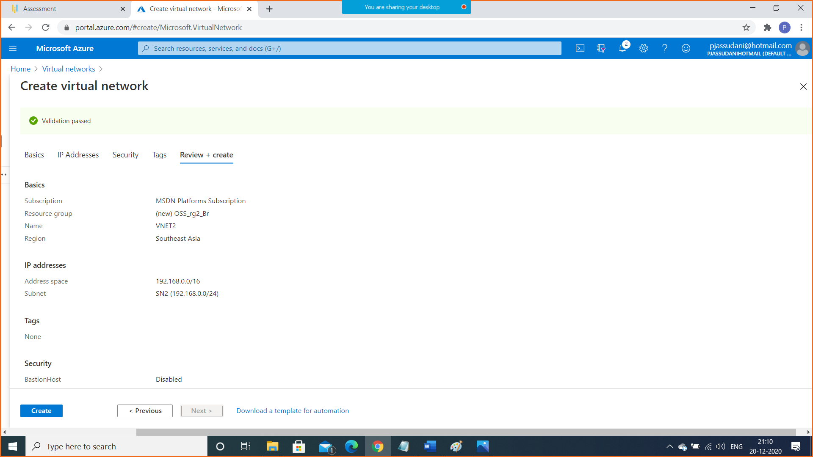

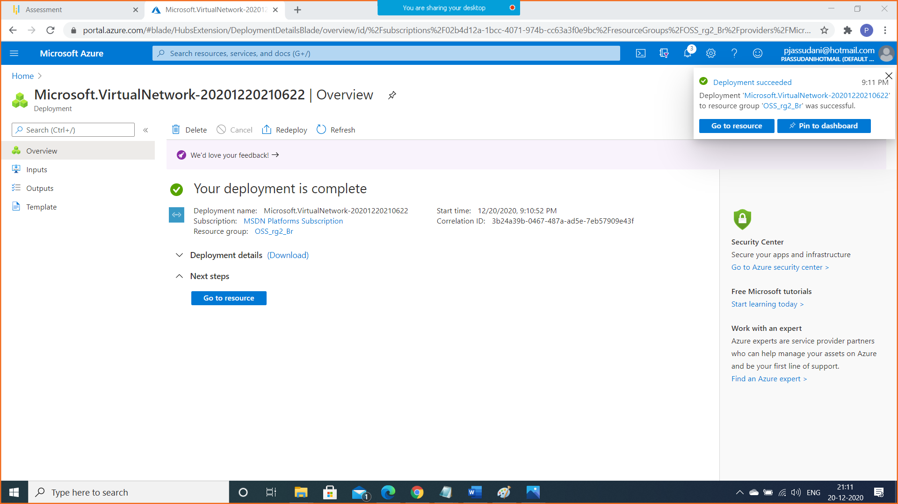

1. Step2: Create test virtual machines in both the virtual networks

Step A: Create First Virtual Machine in HeadQuaters (East US) Region

Resource Group Name: OSS_rg1_HQ

Virtual Machine Name: VM1-HQ

VNET Name: VNET1

Subnet Name: SN1

Location: East US

OS Type: Windows 2016 Datacenter-Gen1

Instance Size: Standars_DS1_v2

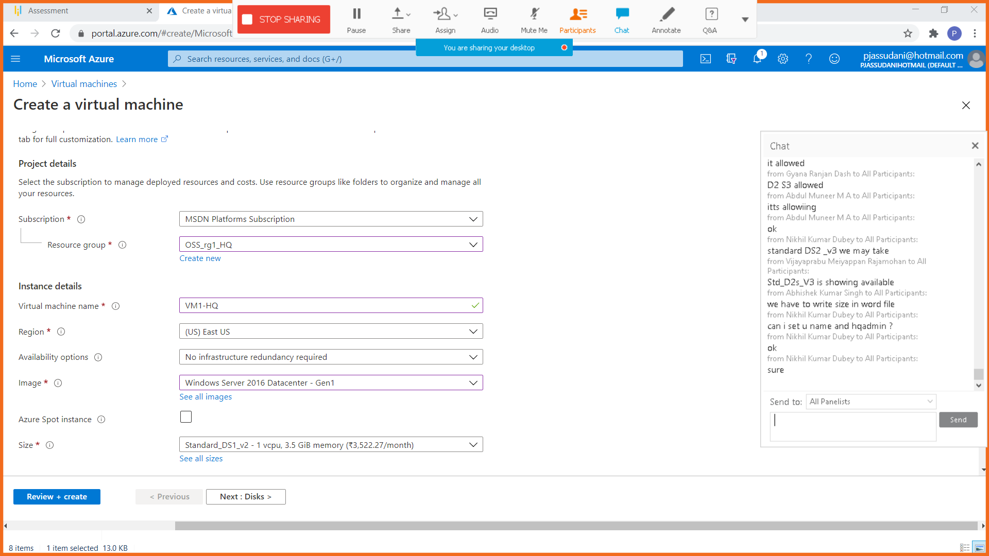

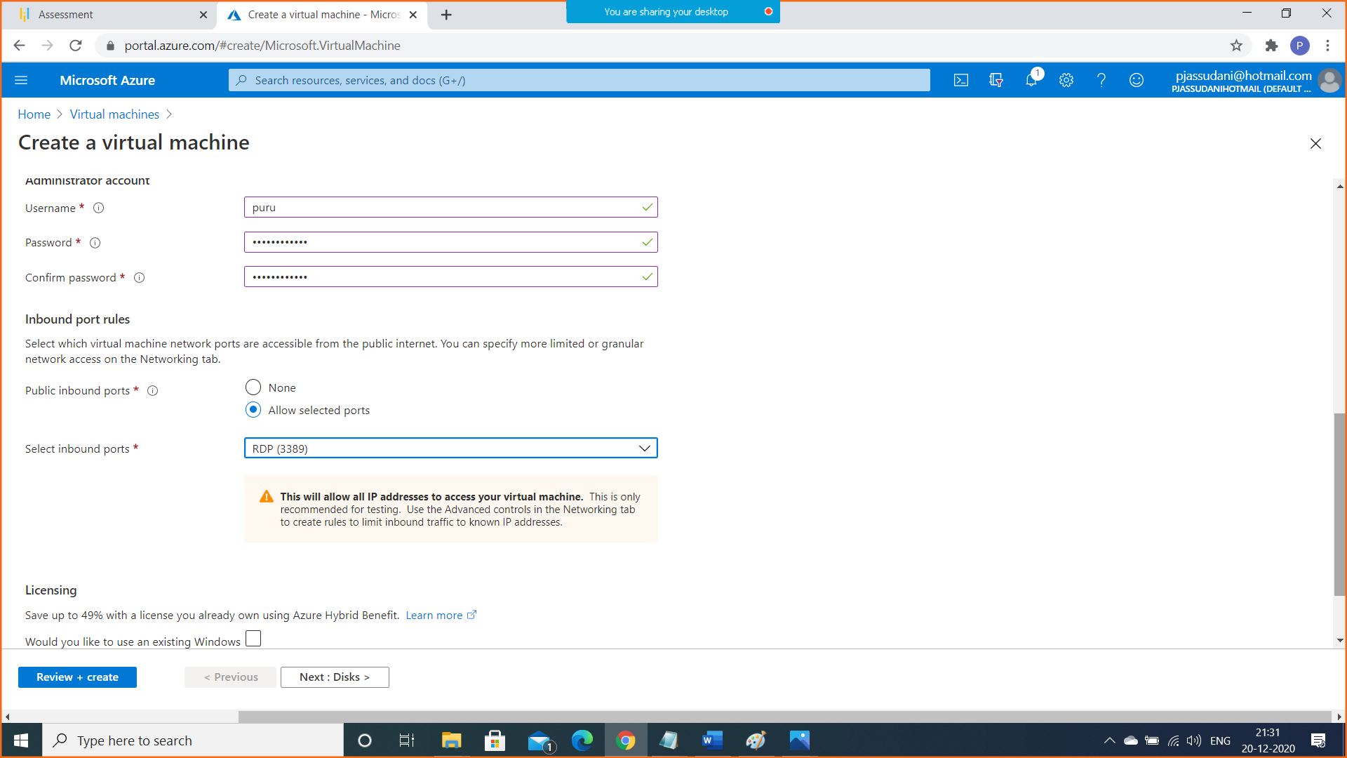

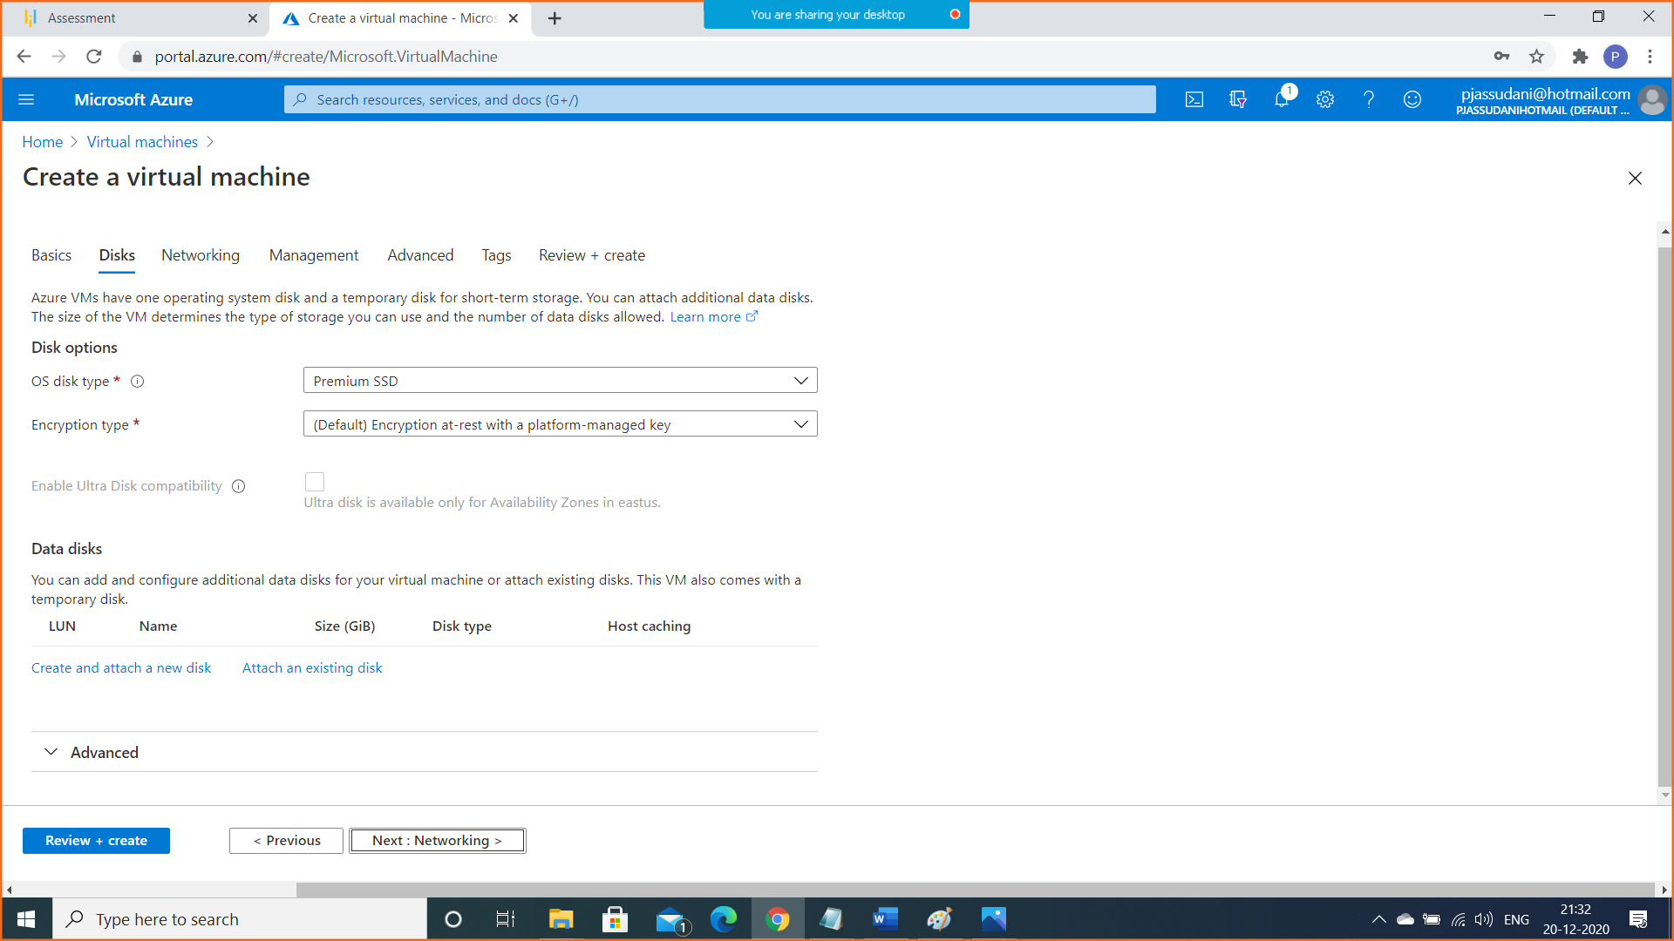

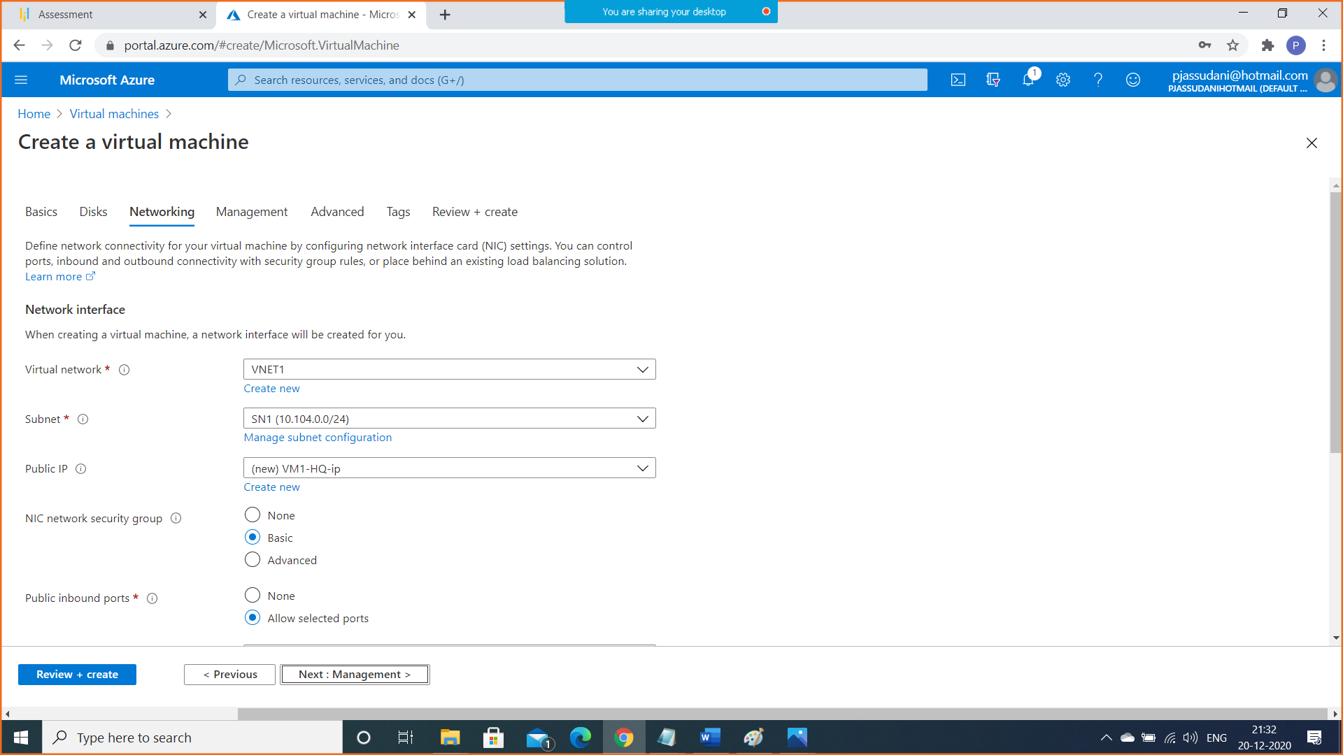

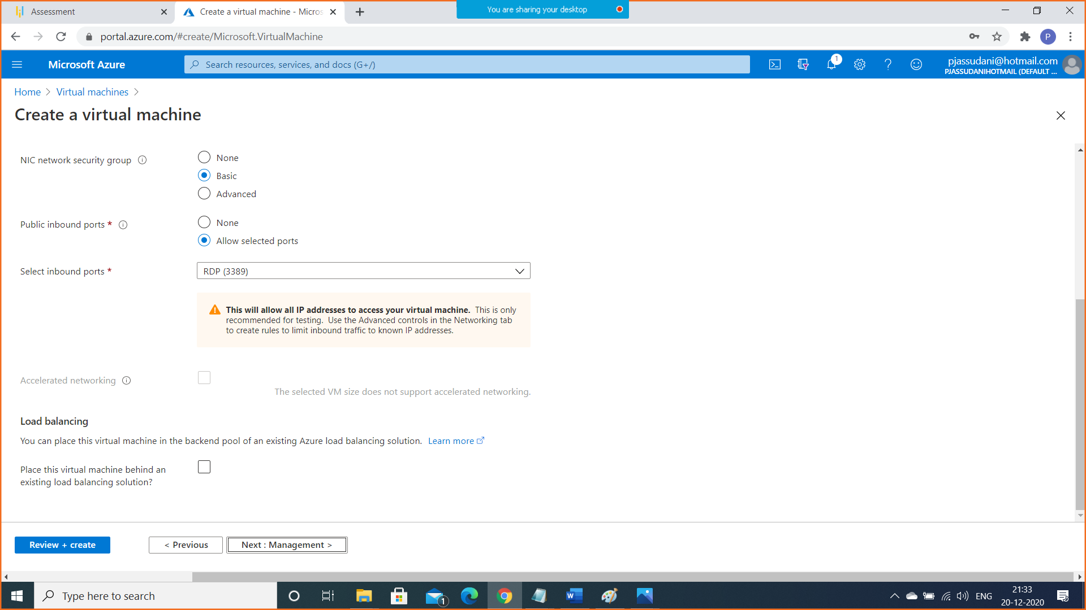

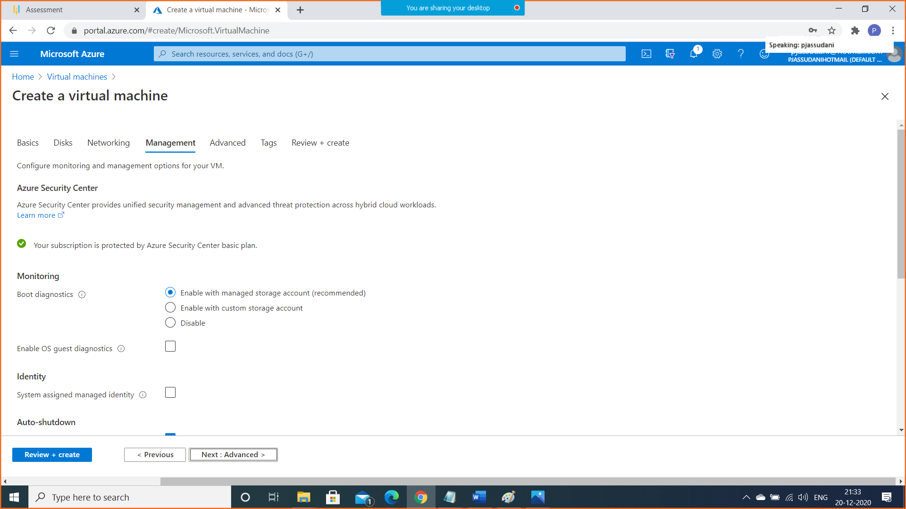

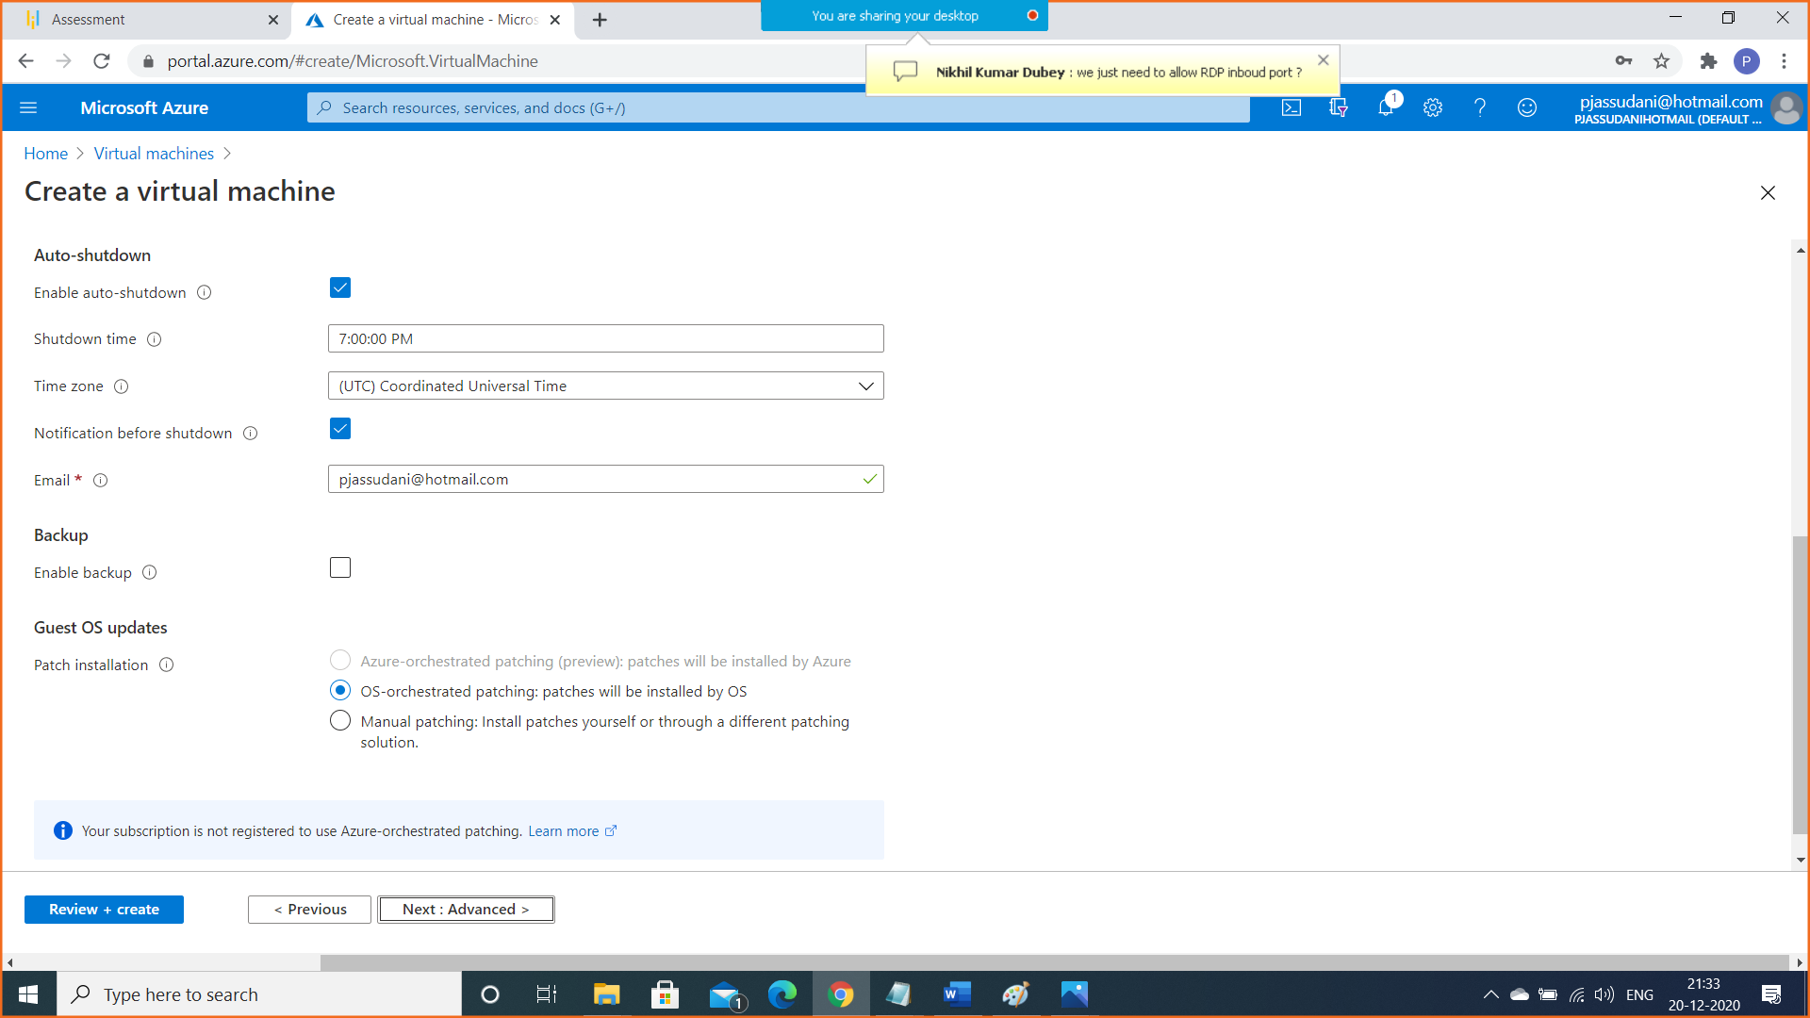

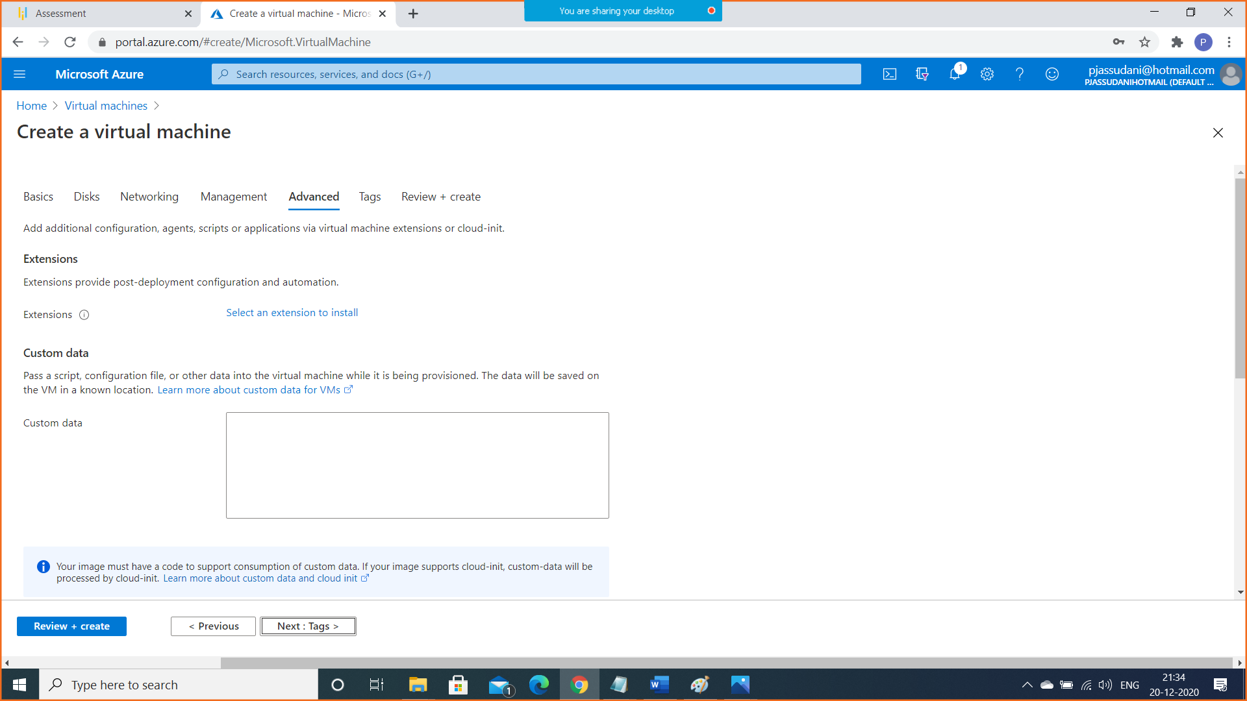

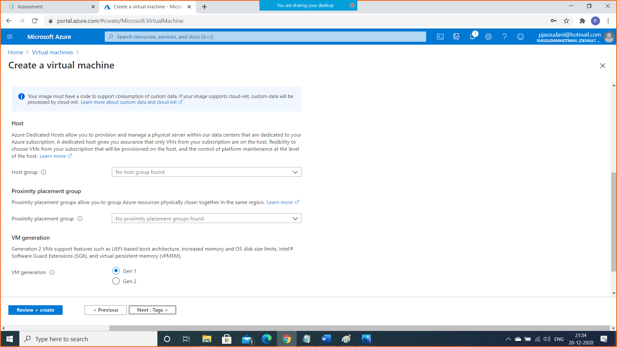

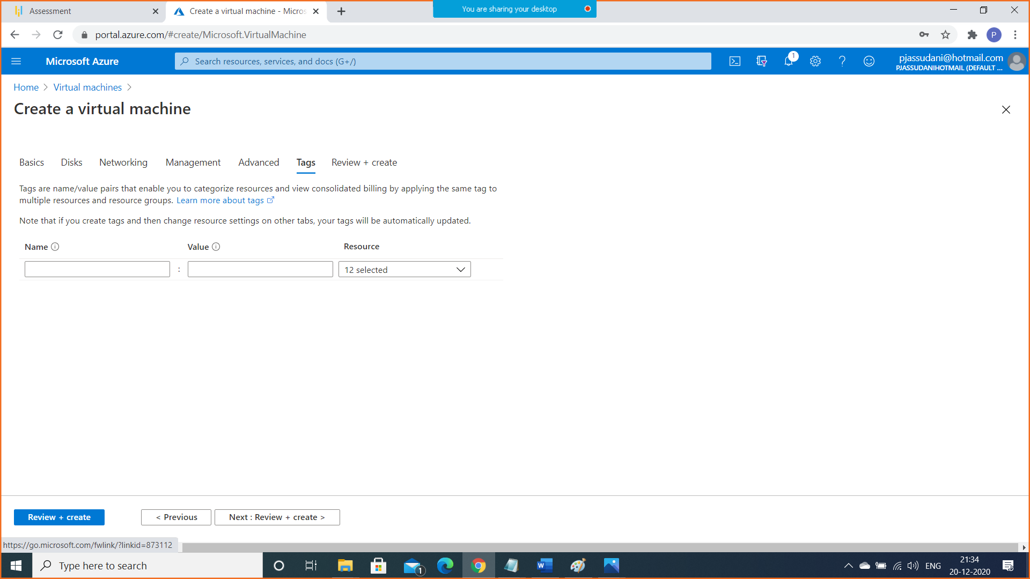

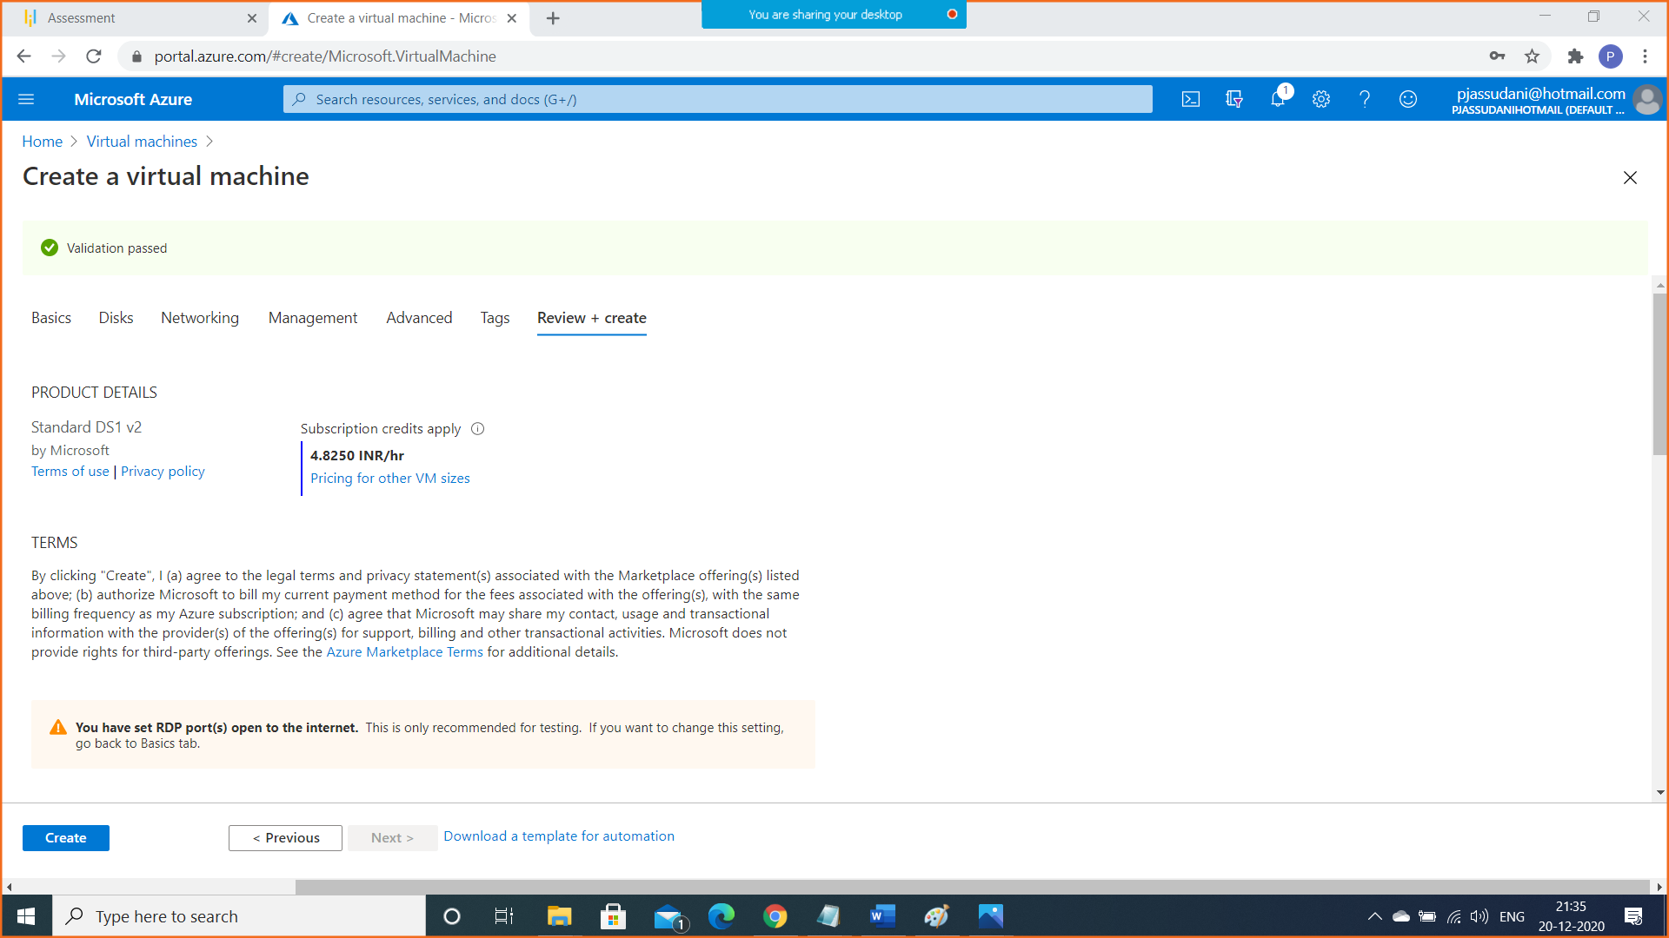

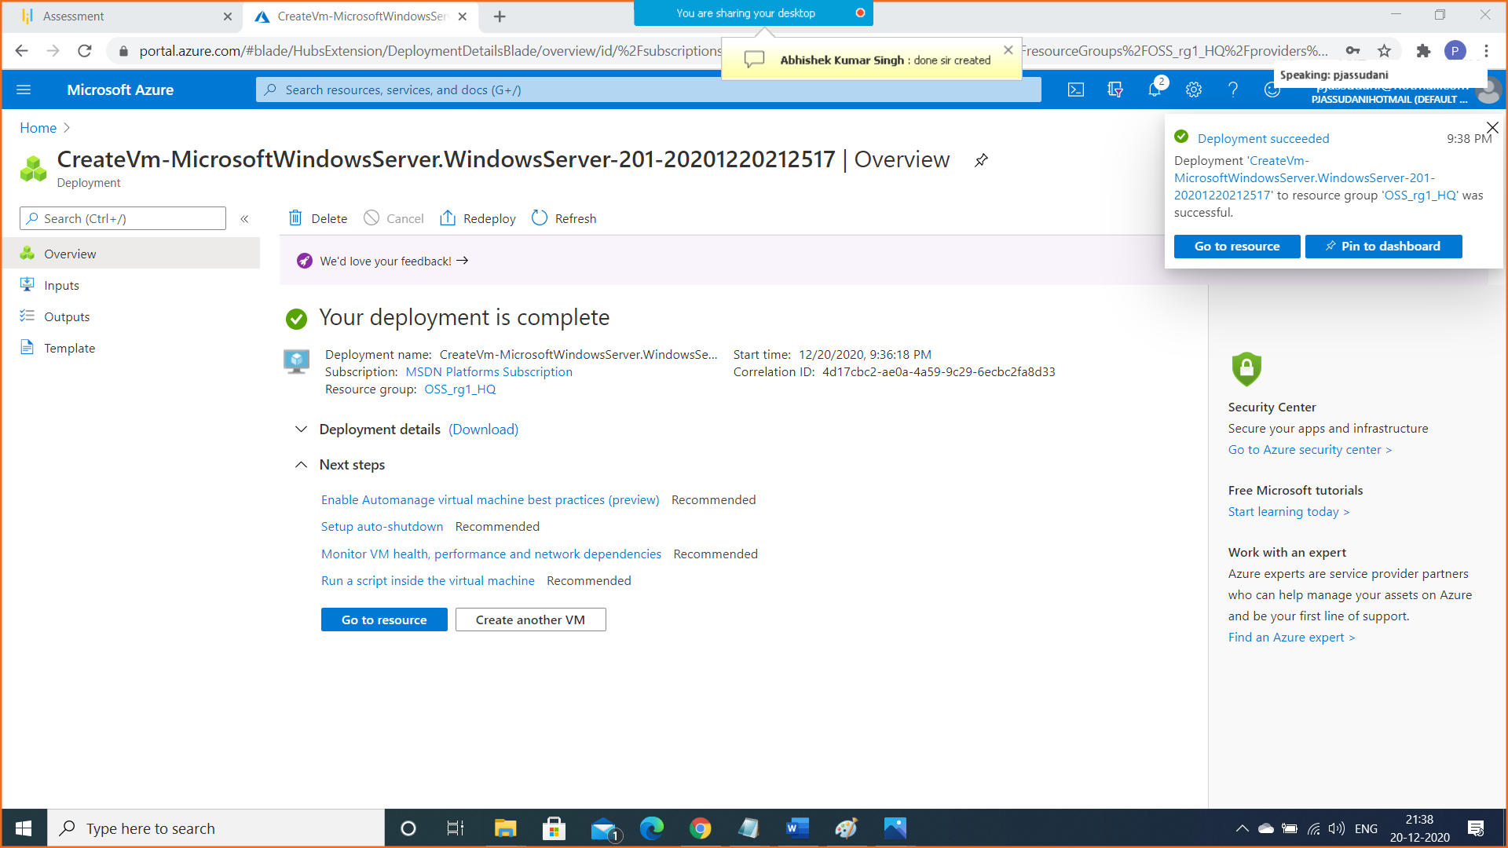

Step B: Create Second Virtual Machine in Branch Office (South East Asia) Region

Resource Group Name: OSS_rg2_Br

Virtual Machine Name: VM2-BR

VNET Name: VNET2

Subnet Name: SN2

Location: South East Asia

OS Type: Windows 2016 Datacenter-Gen1

Instance Size: Standars_DS1_v2

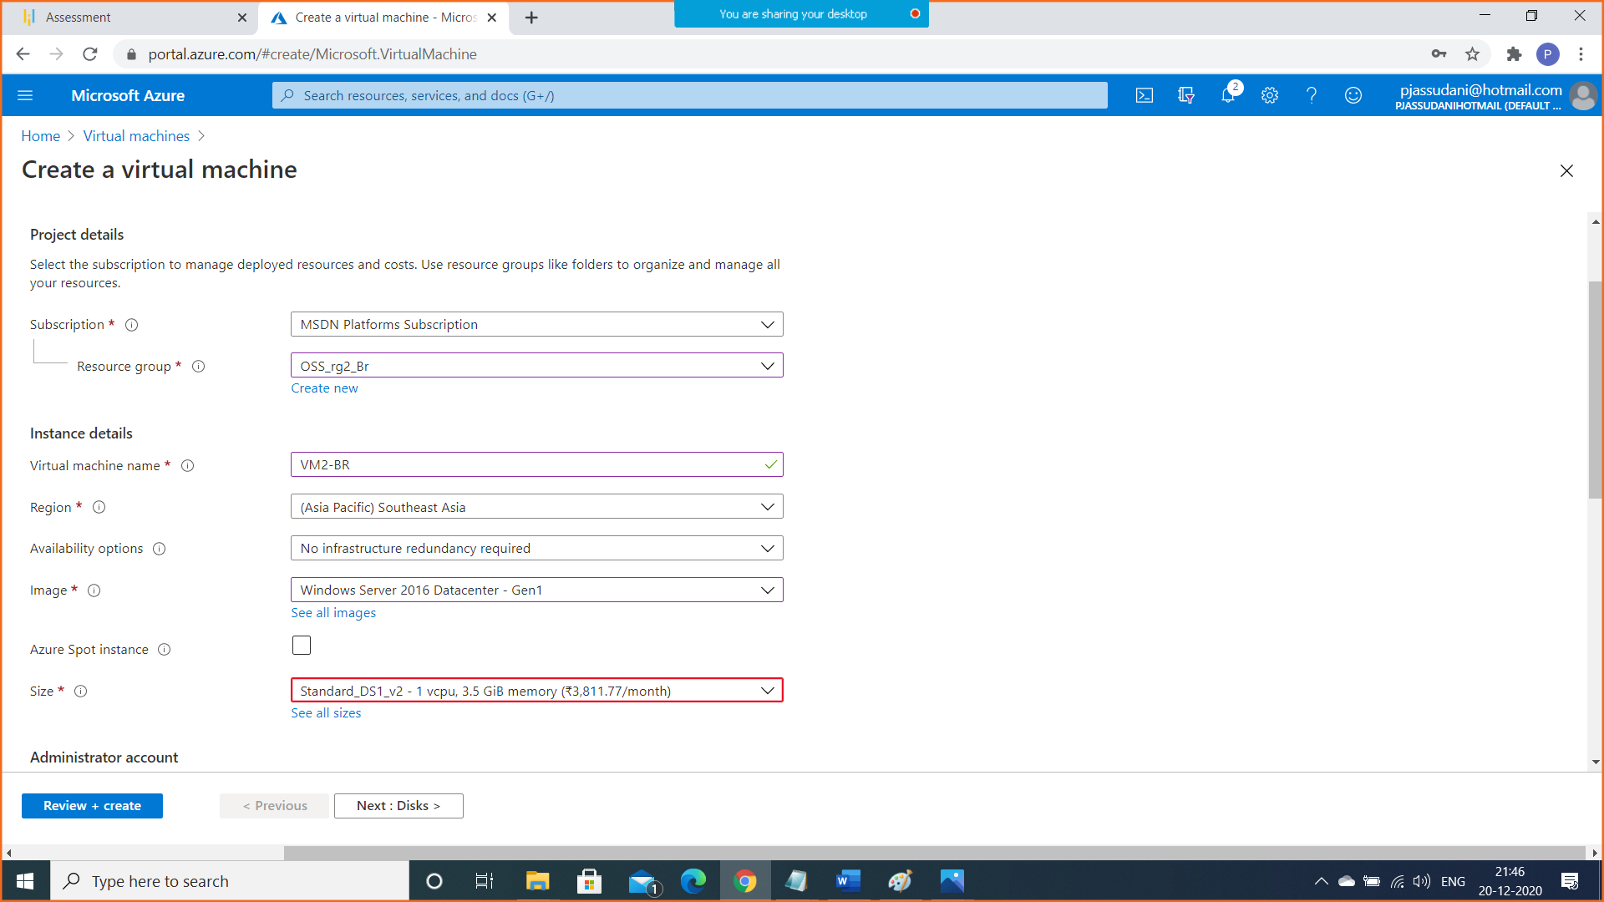

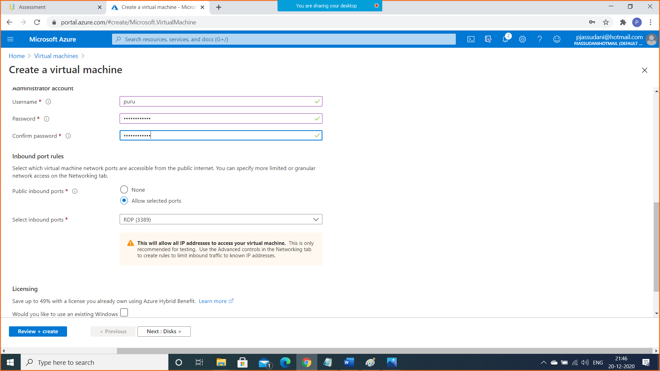

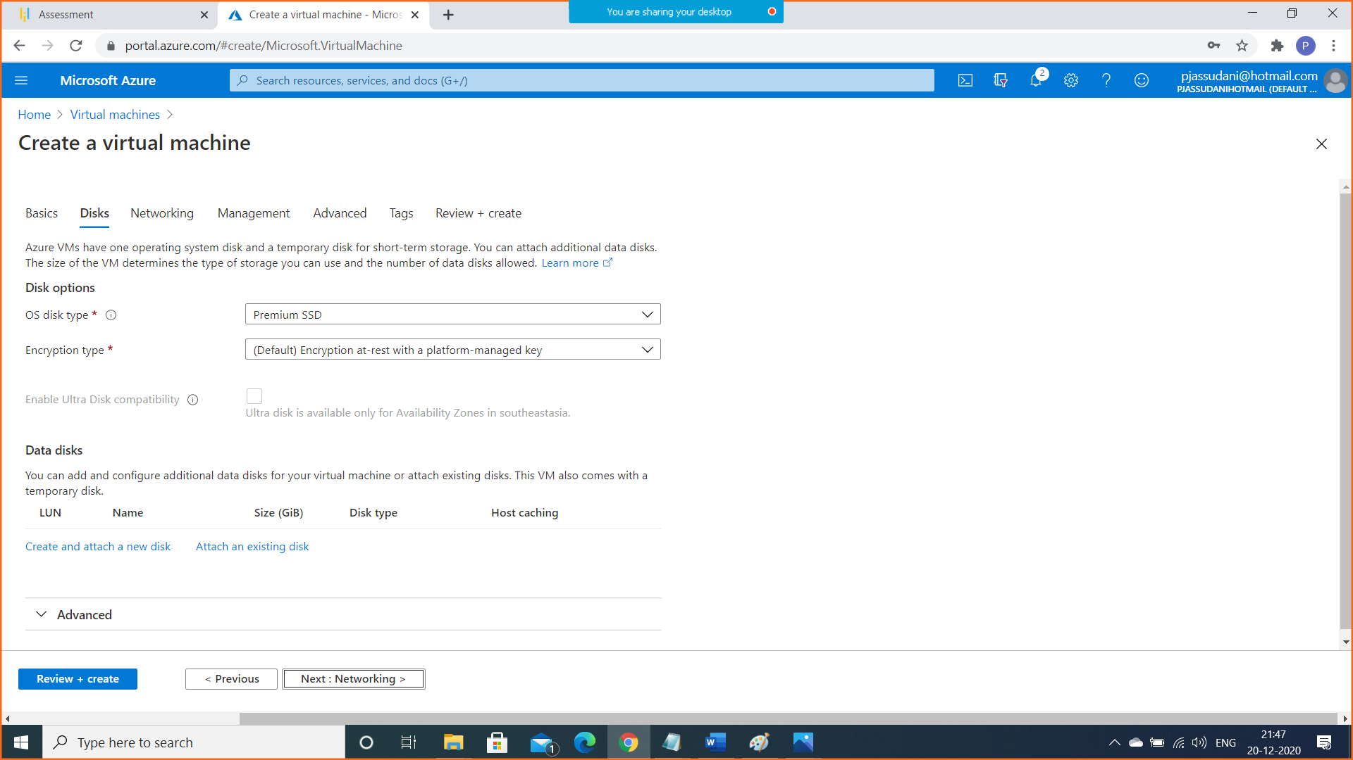

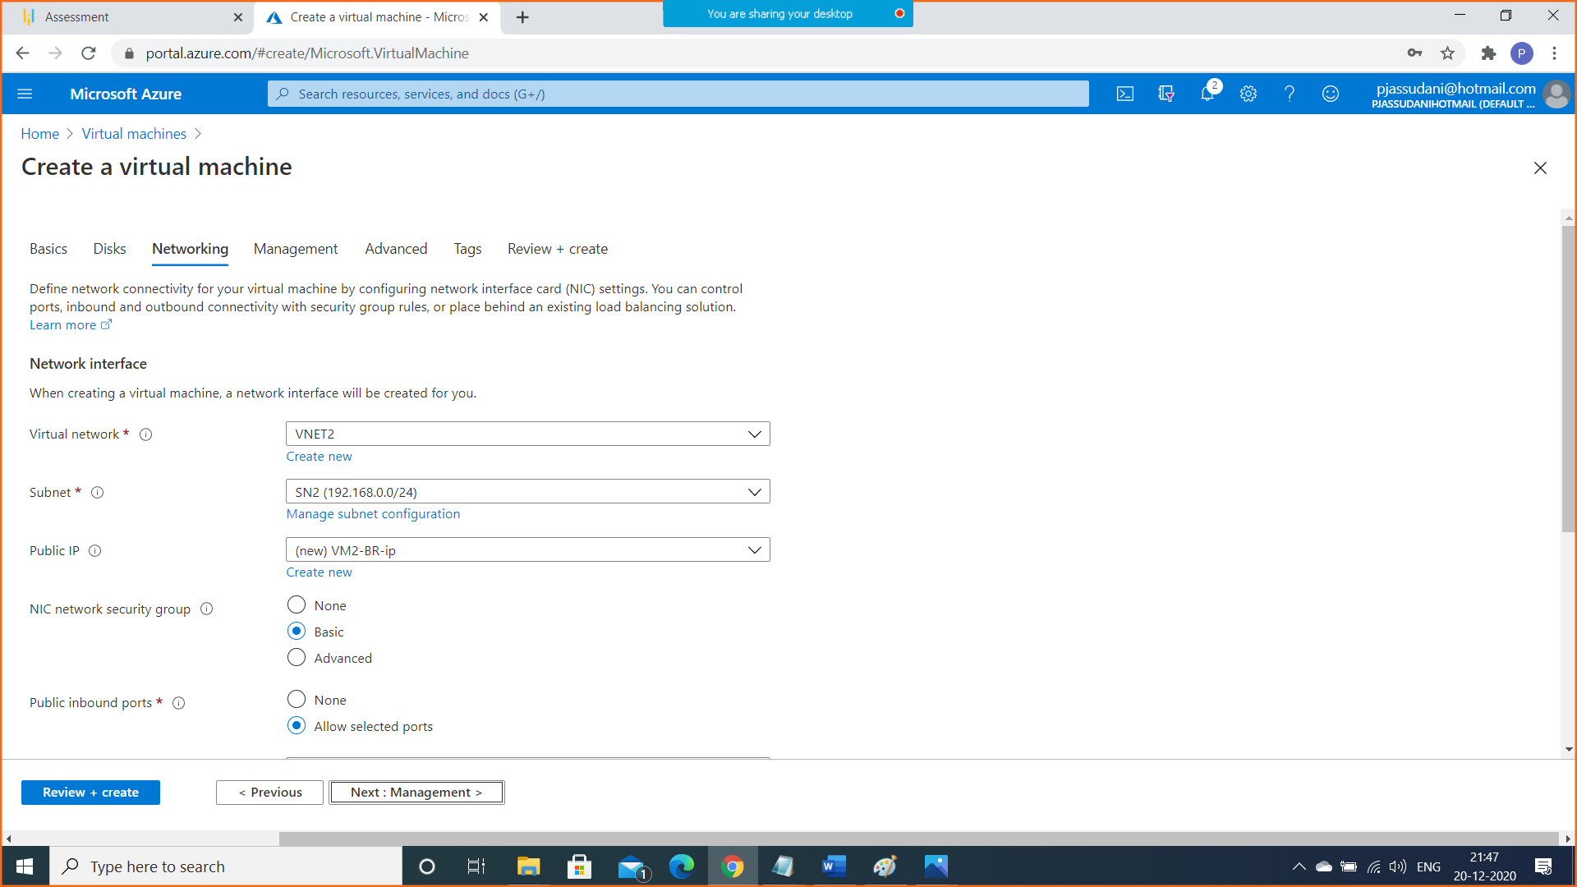

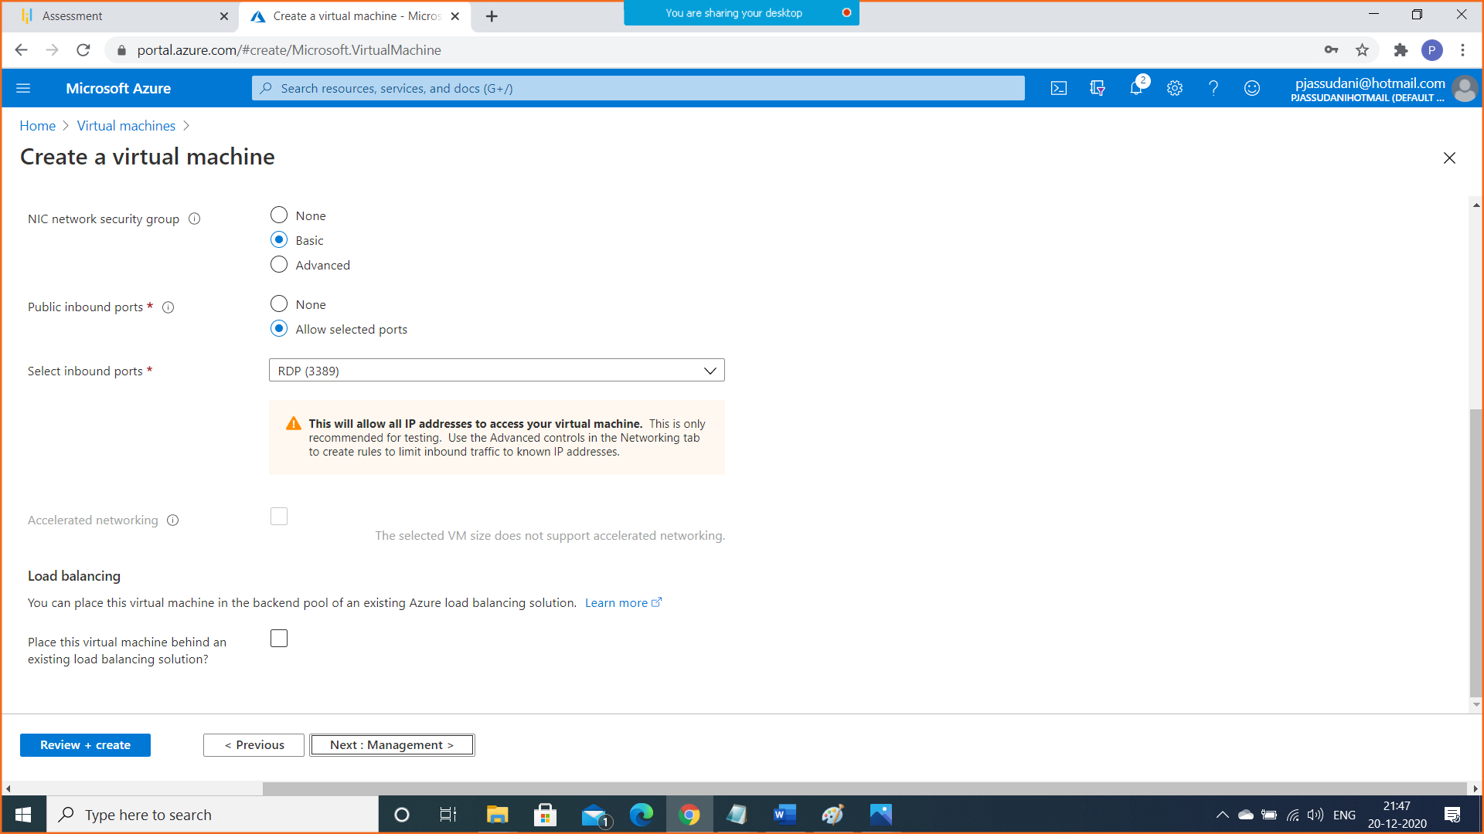

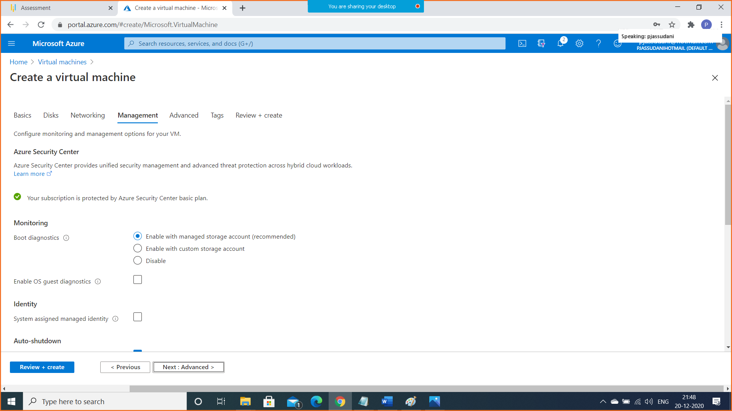

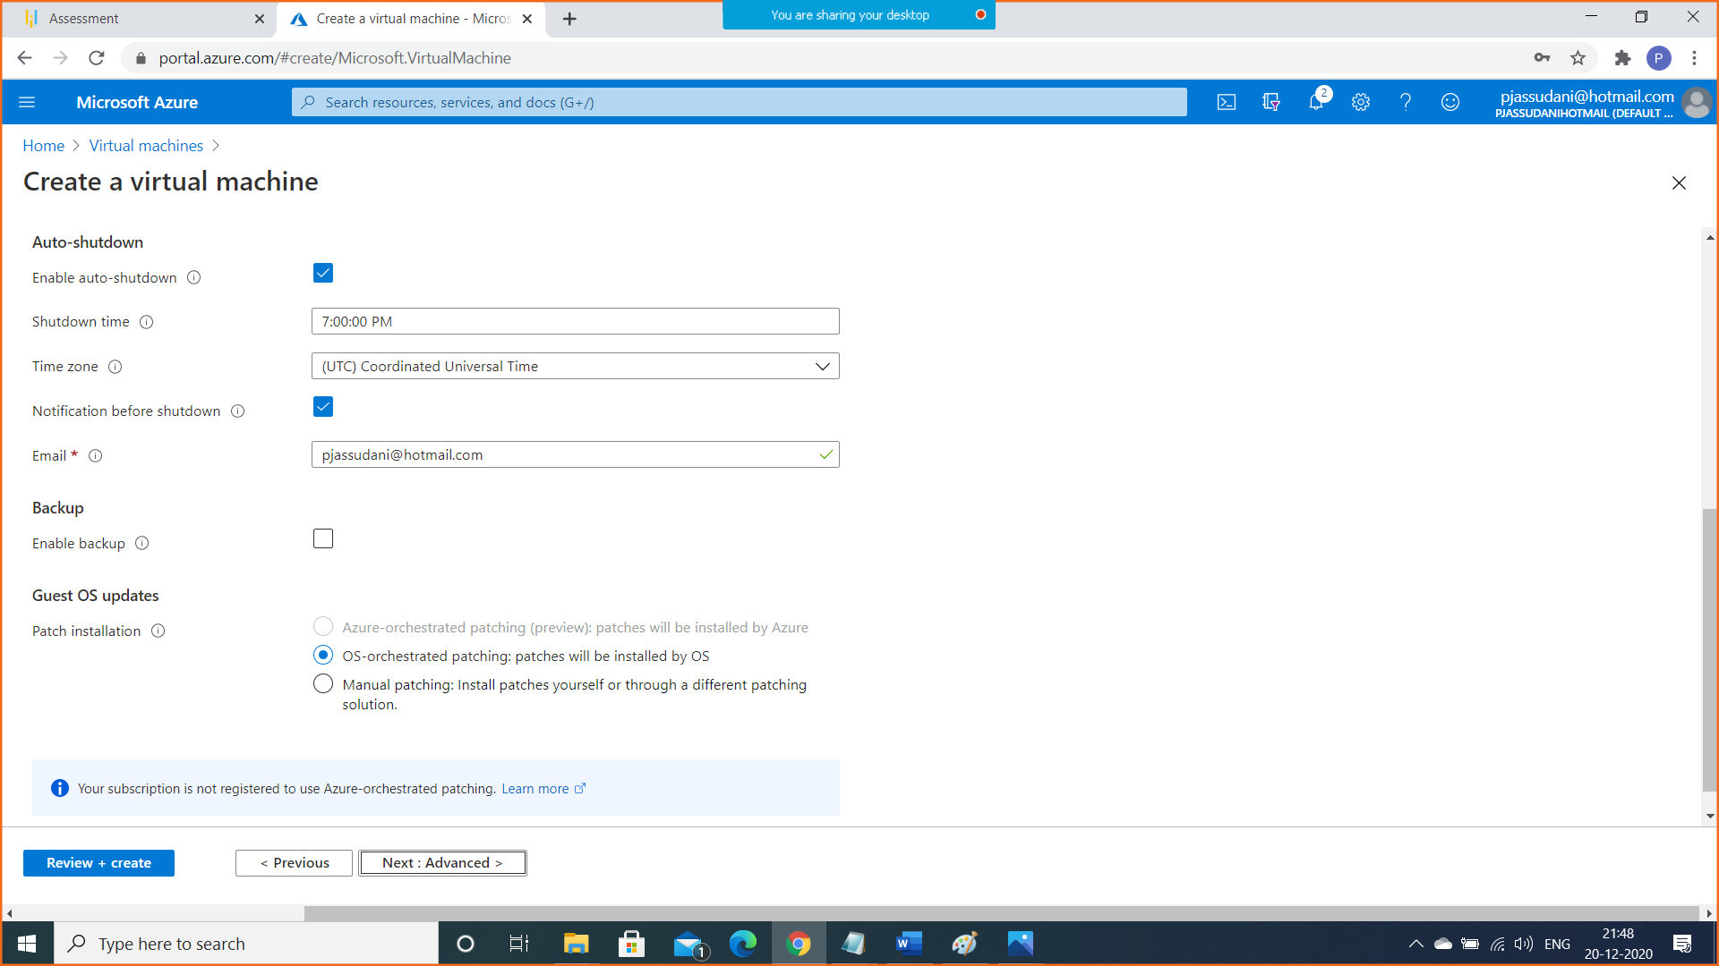

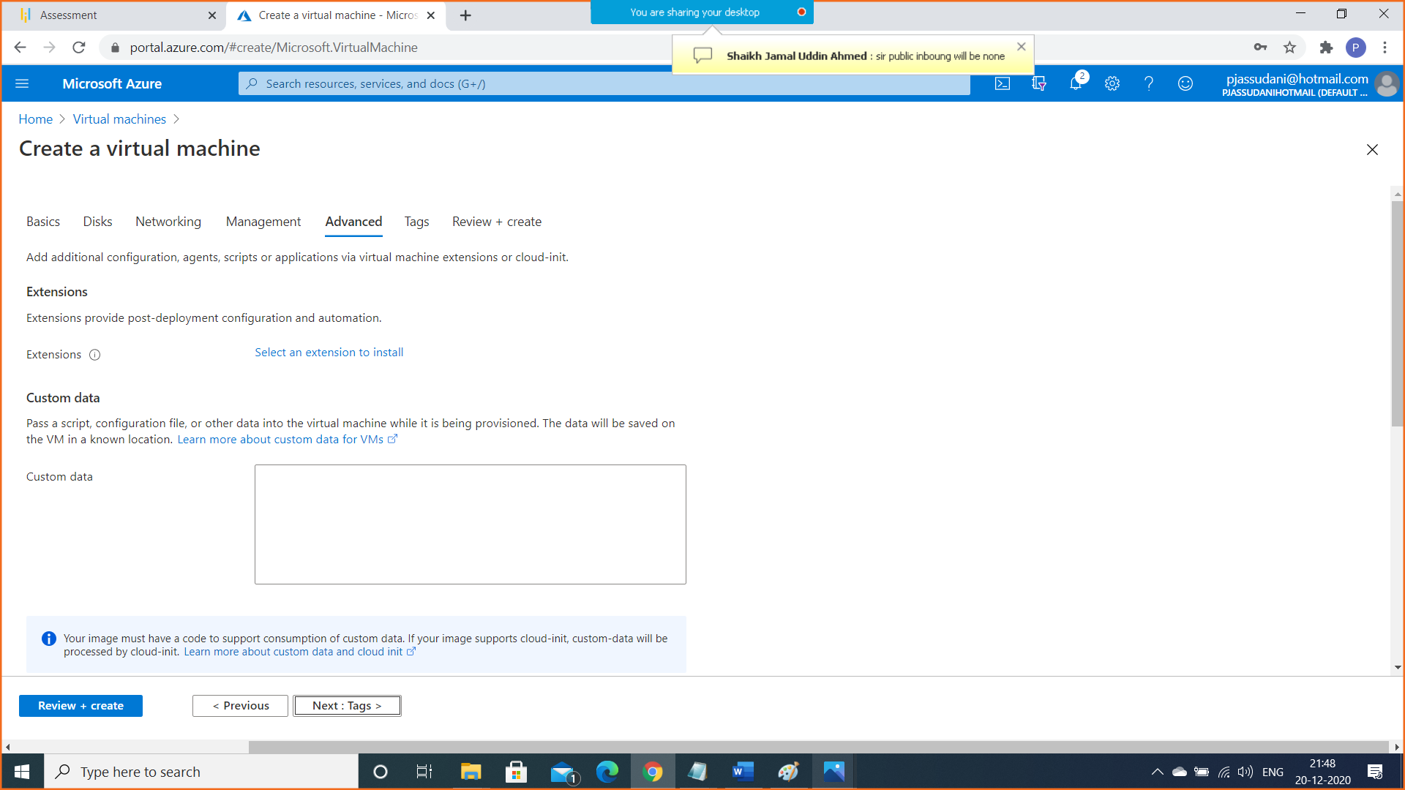

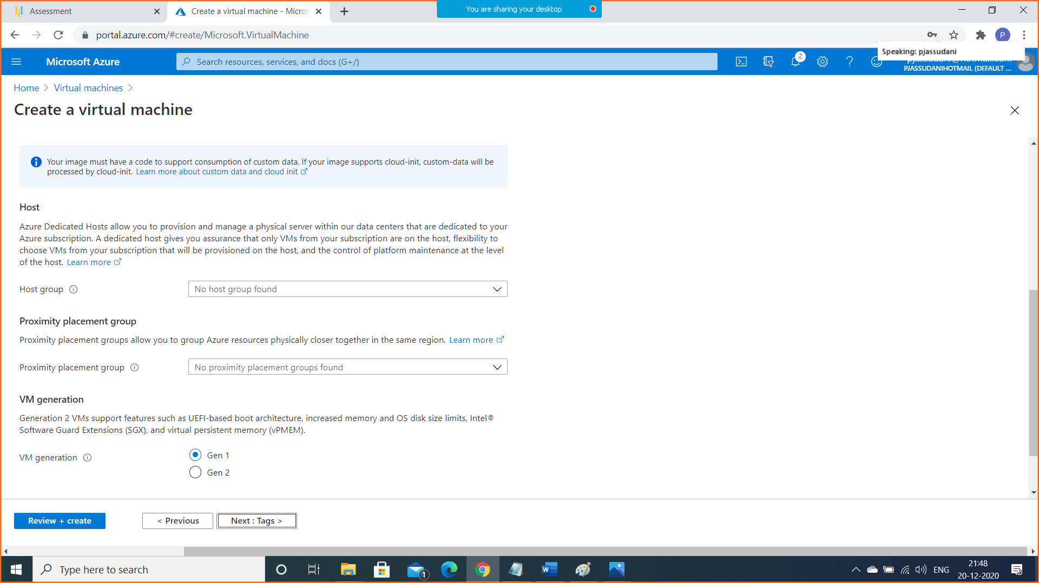

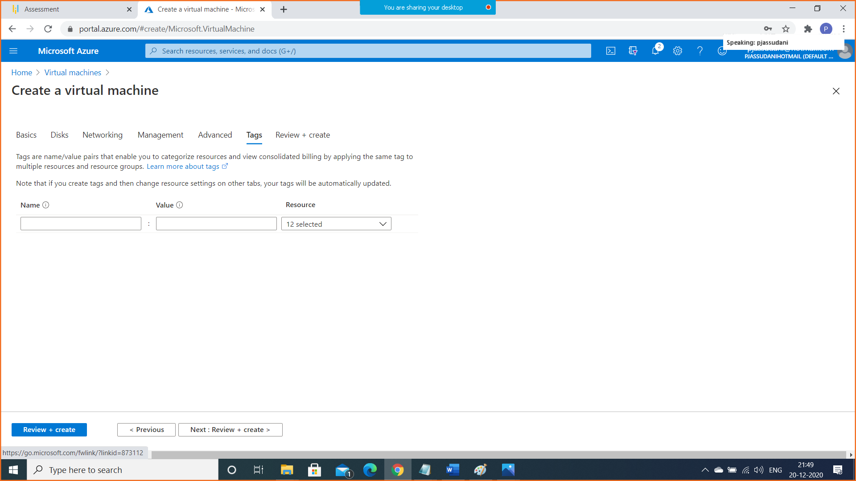

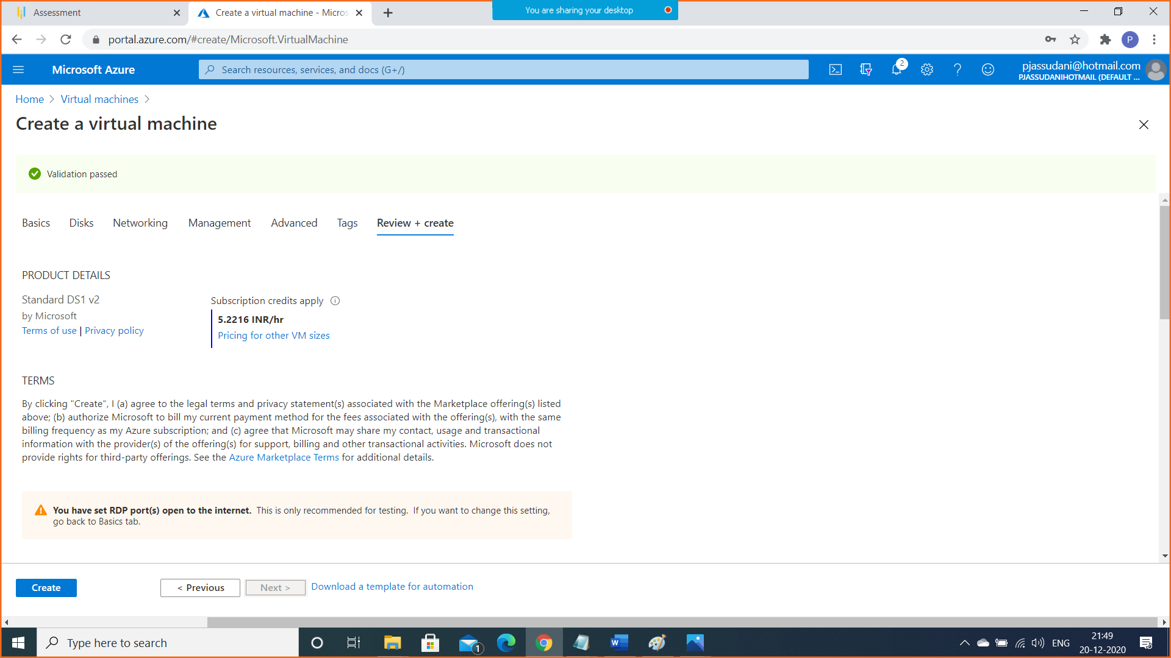

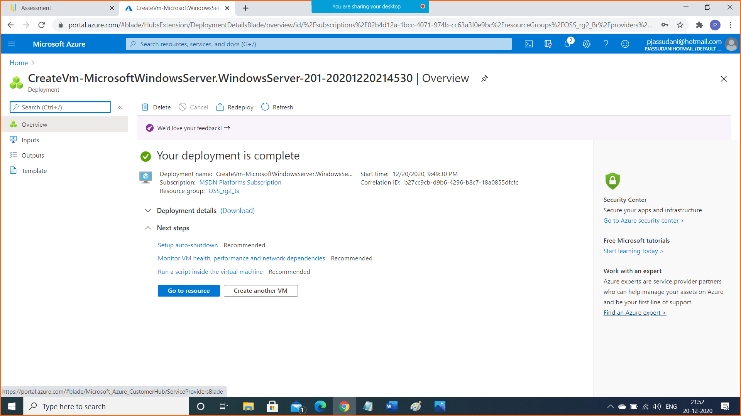

1. Step 3: Establish the connectivity between both the networks via VNet peering
2. First got to virtual Networks Tab
3. Go to First Virtual Network i.e. VNET1
4. Go to peerings tab in VNET1

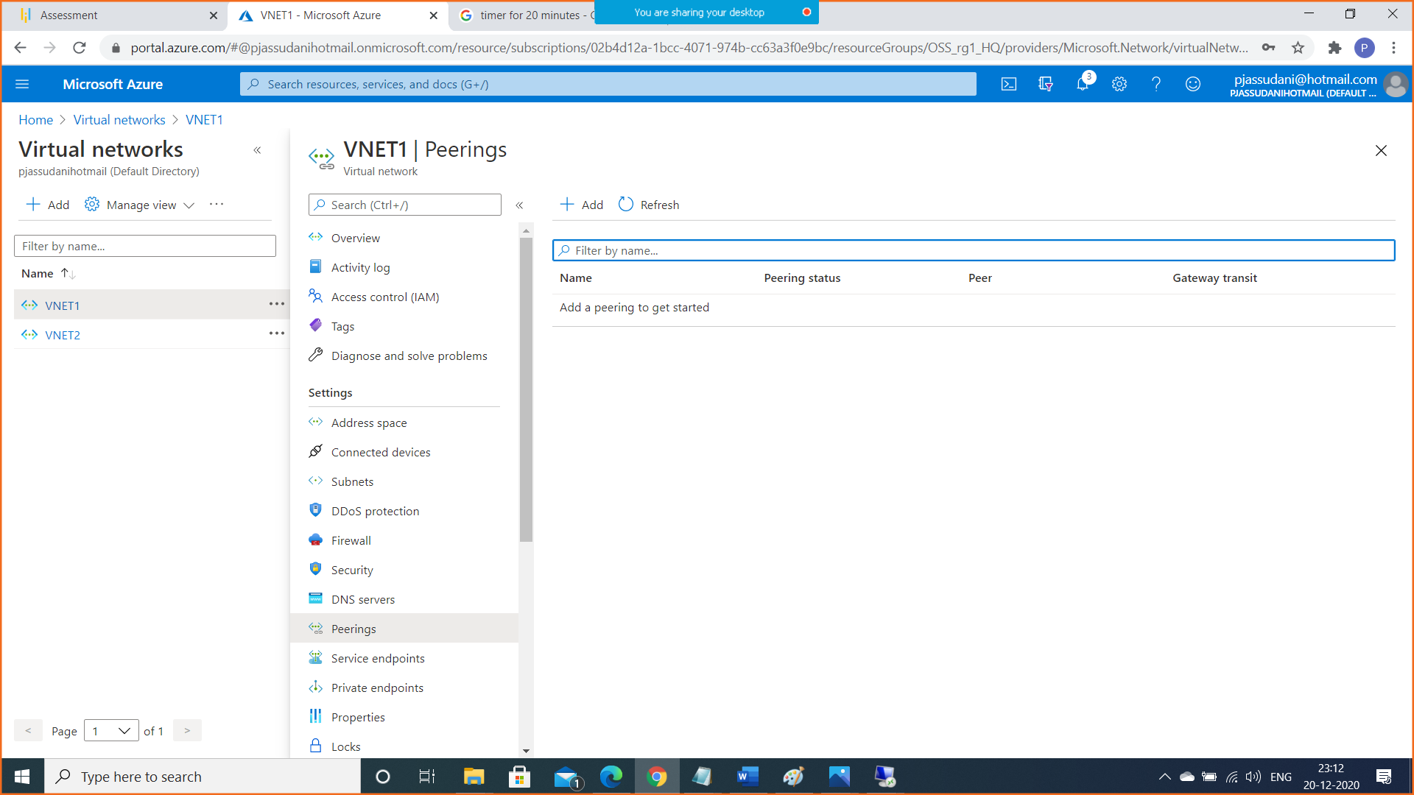

1. Click on Add and do the setting shown in the snapshots below

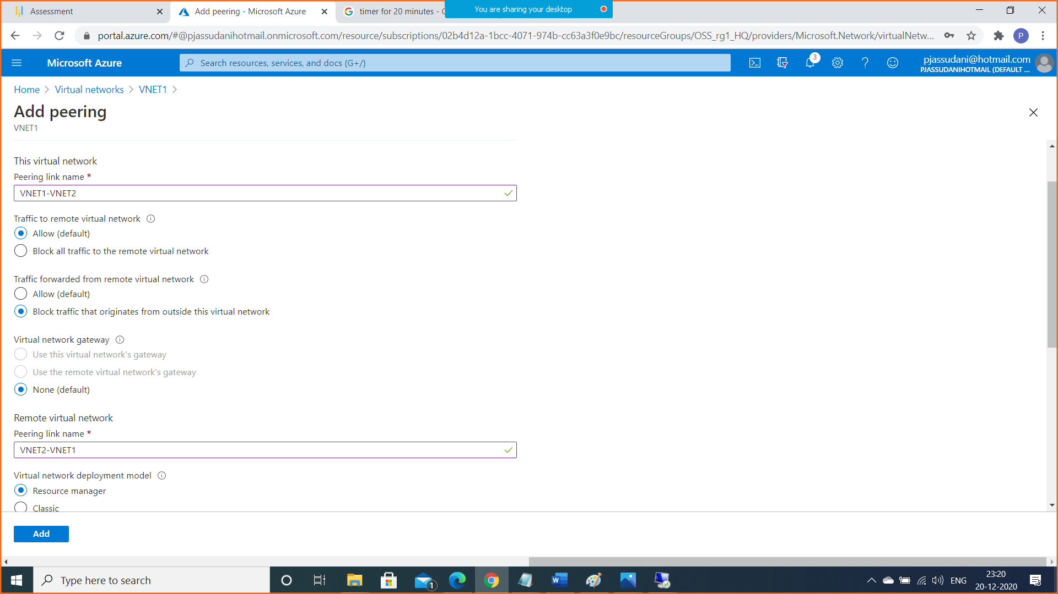

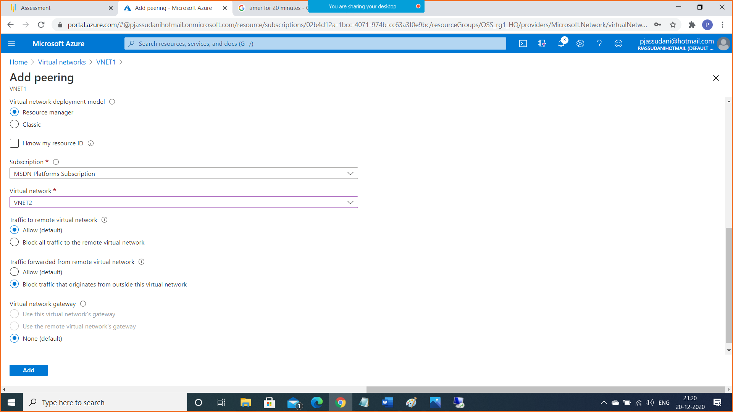

Now click on Add

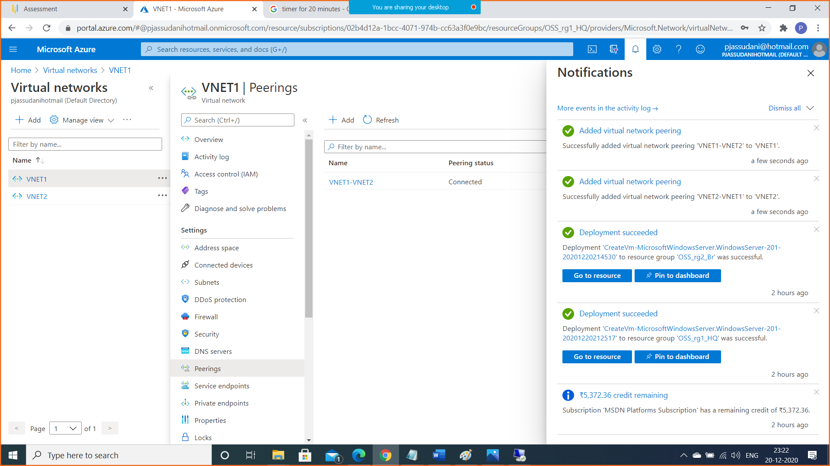

1. Step4: Ensure connectivity is established properly
2. Connect to First Virtual Machine (VM1-HQ) East US

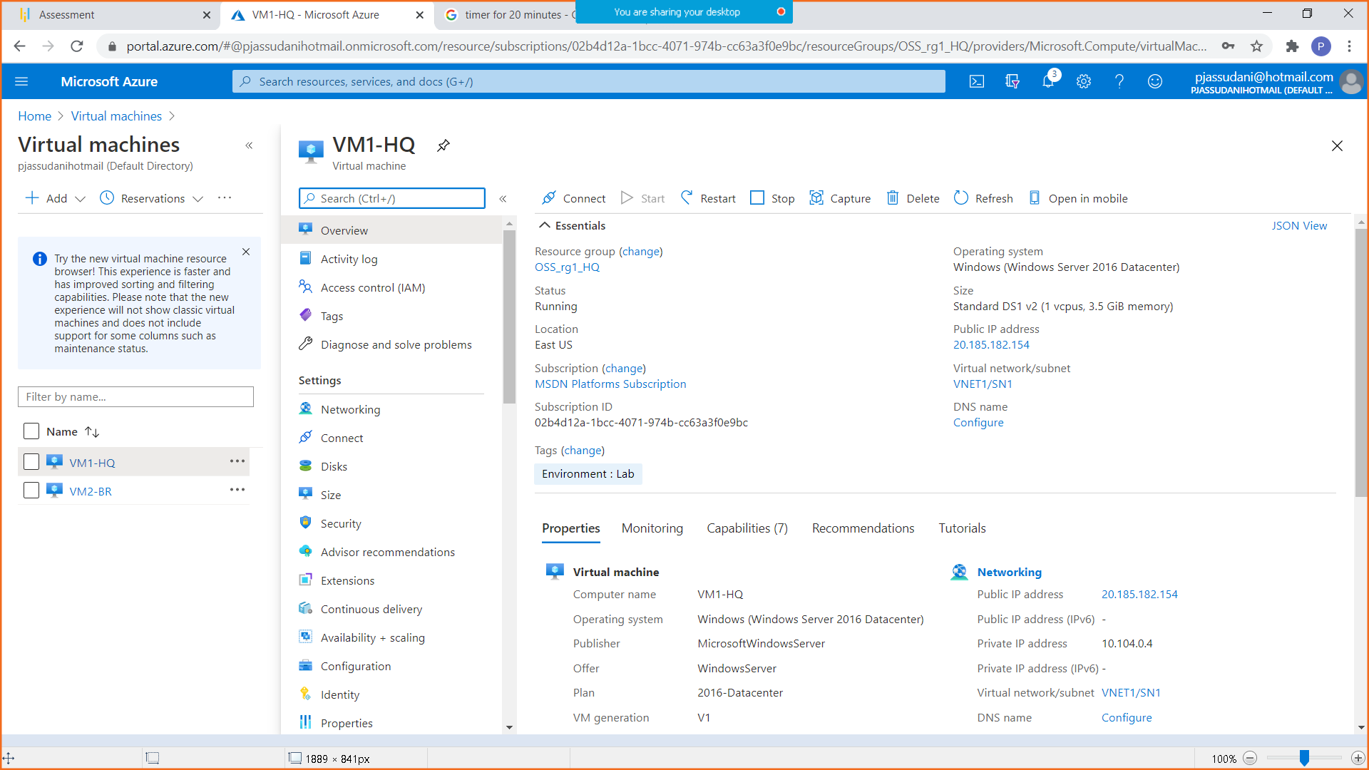

Copy public IP and paste it by doing MSTSC

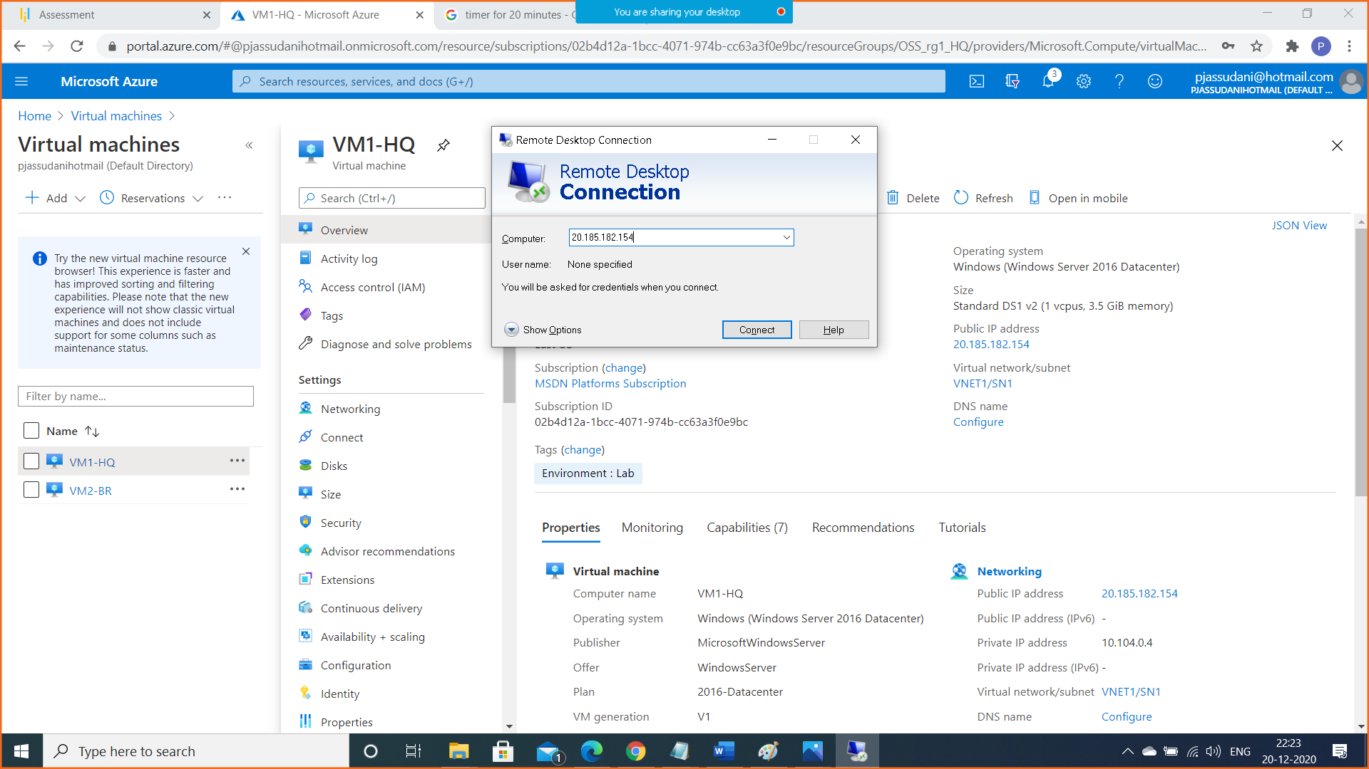

Put username and password

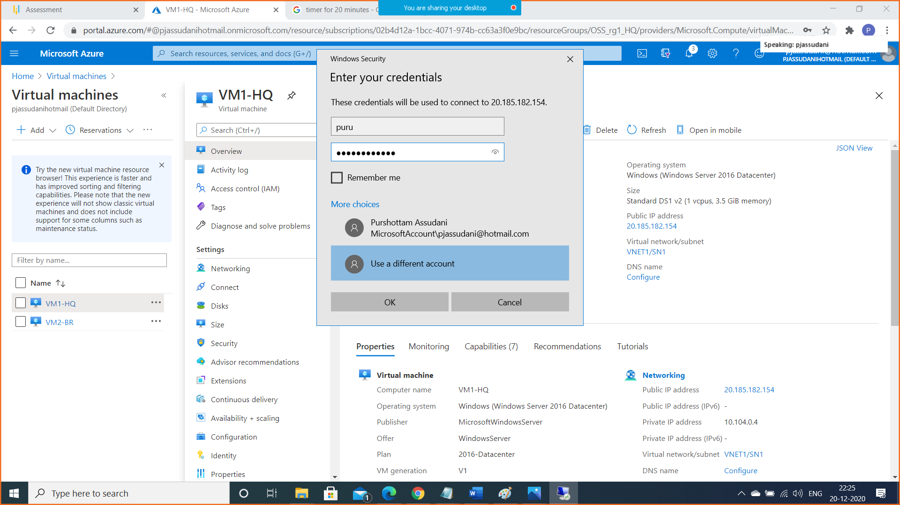

1. Connect to Second Virtual Machine (VM2-Br) South East Asia

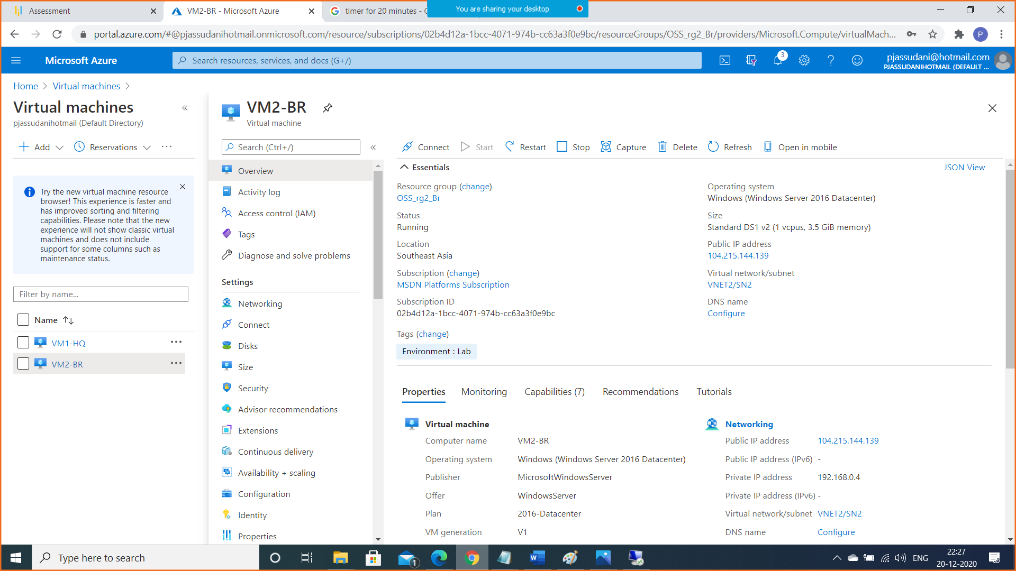

Copy public IP and paste it by doing MSTSC

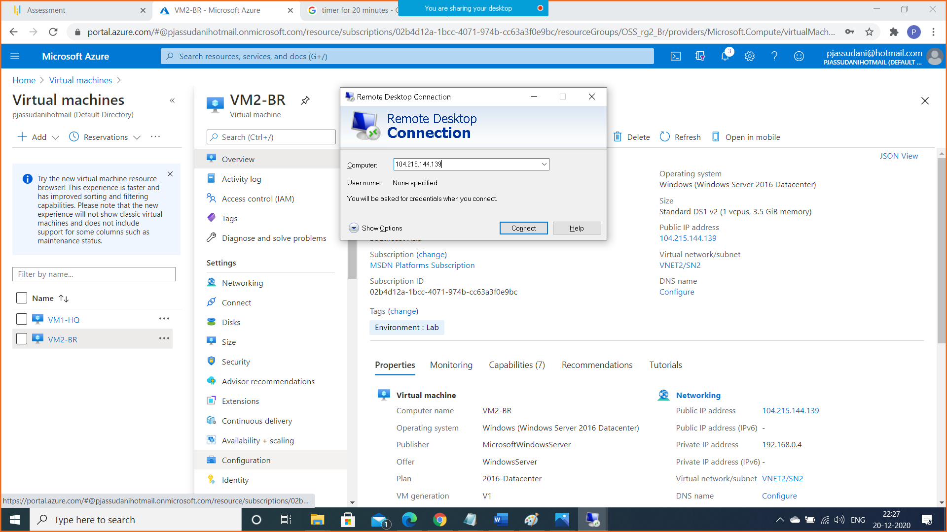

Put username and password

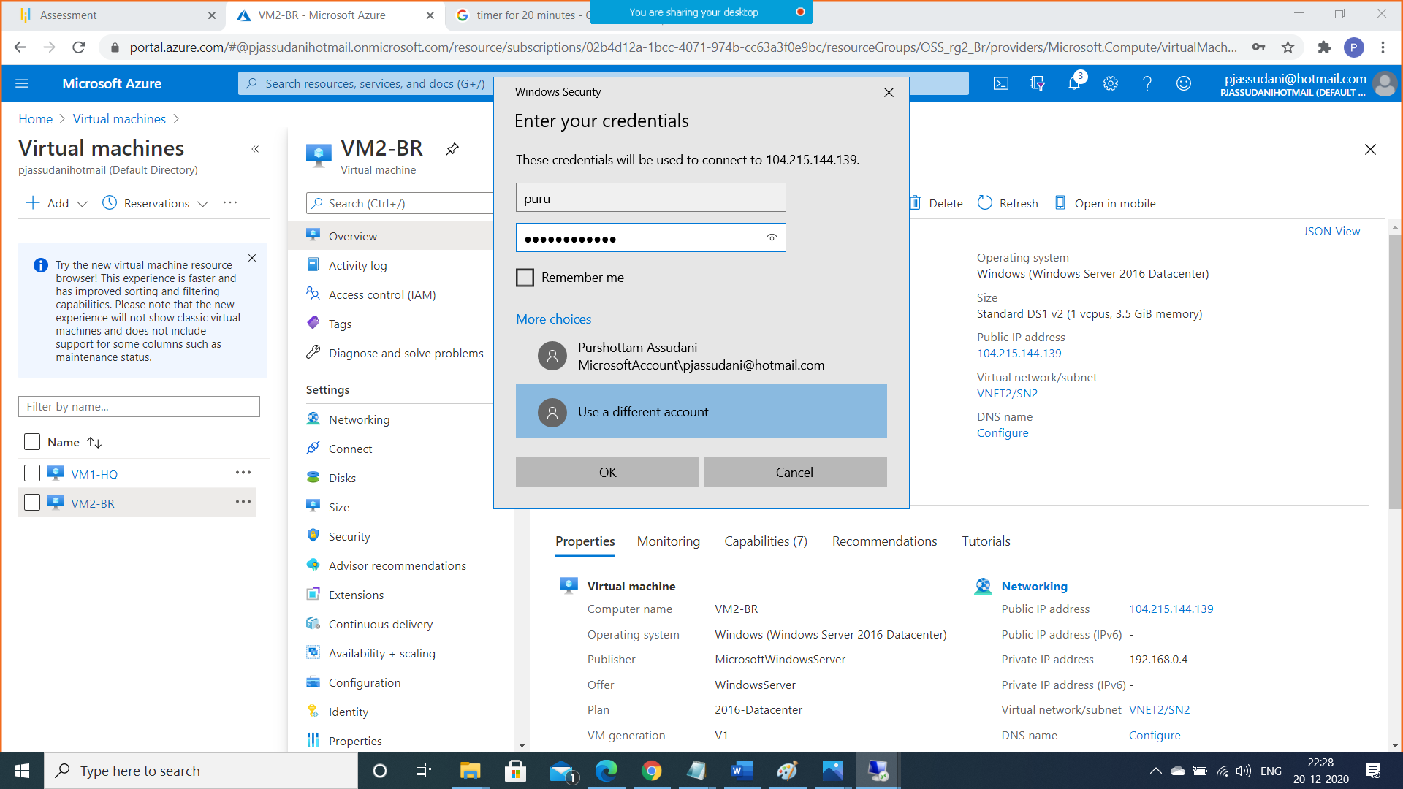

C . Run firewall.cpl in both VMs and then in Advanced Settings allow ICMP traffic in Inbound Rules

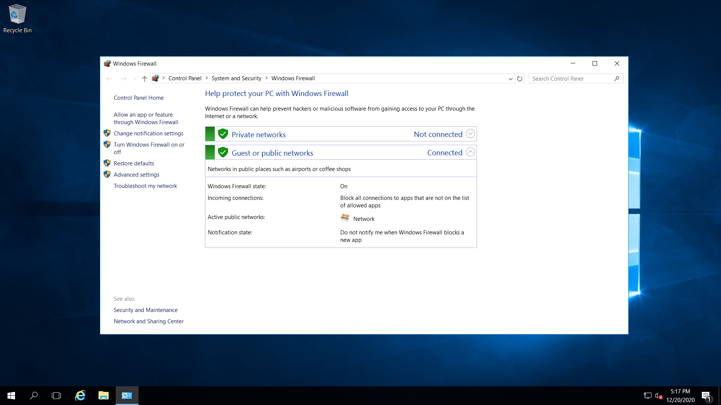

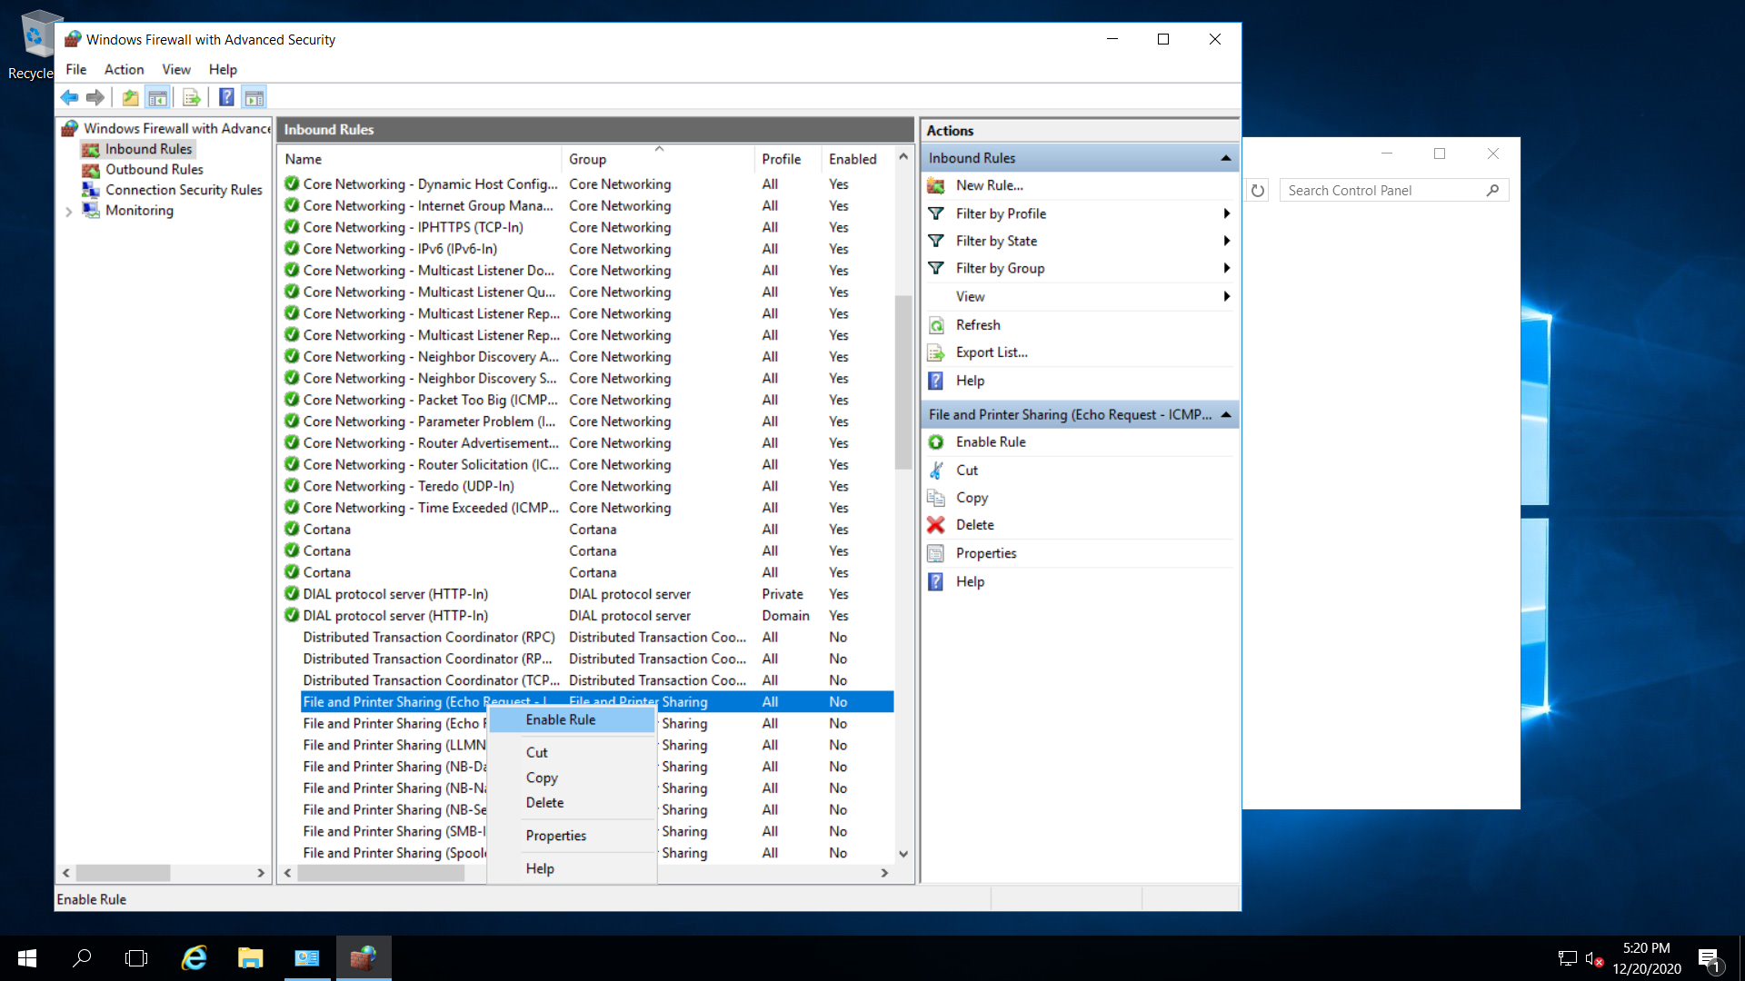

D.Go to Command prompt on both the VMs by typing cmd

Then type ipconfig to check the ips of both VMs and then try to ping both VMs with each other by the command:

Ping <IP of other VM>

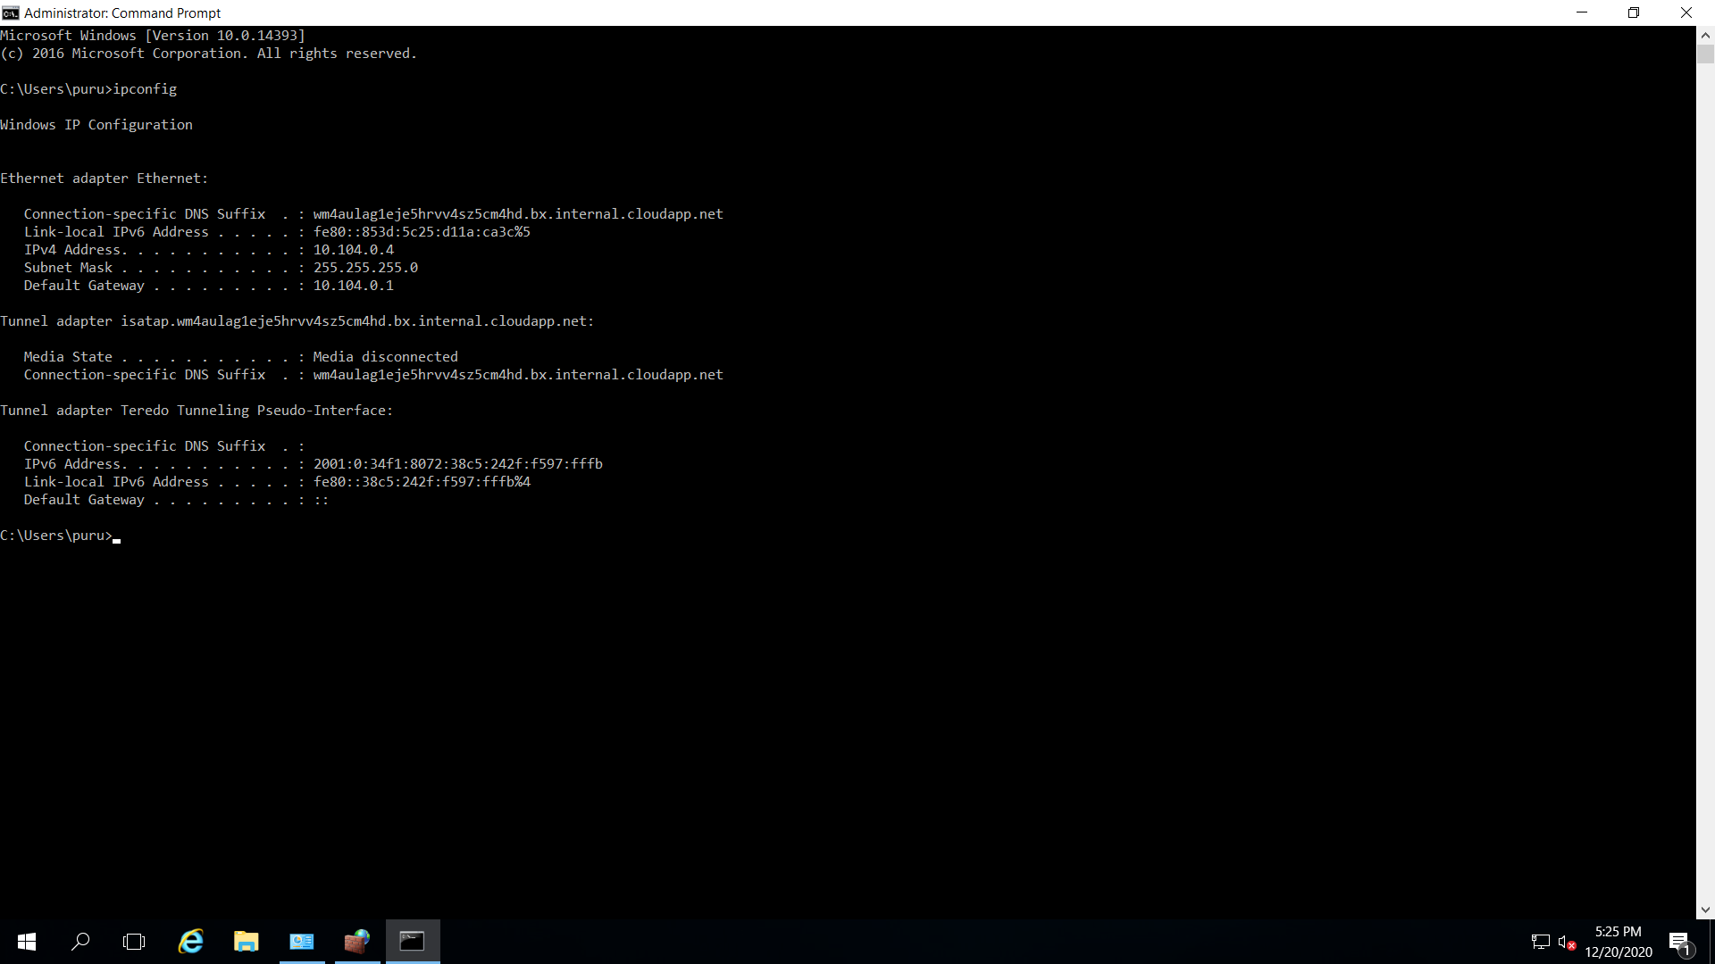

Ping 192.168.0.4

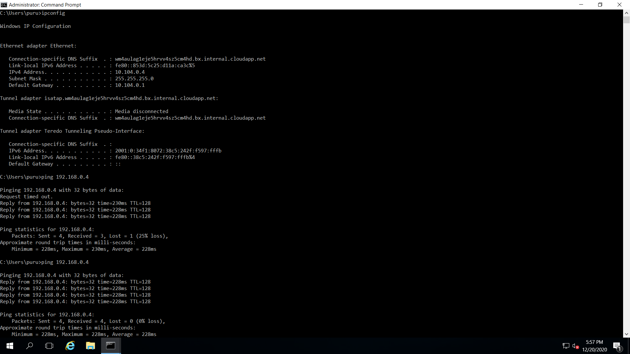

Ping 10.104.0.4

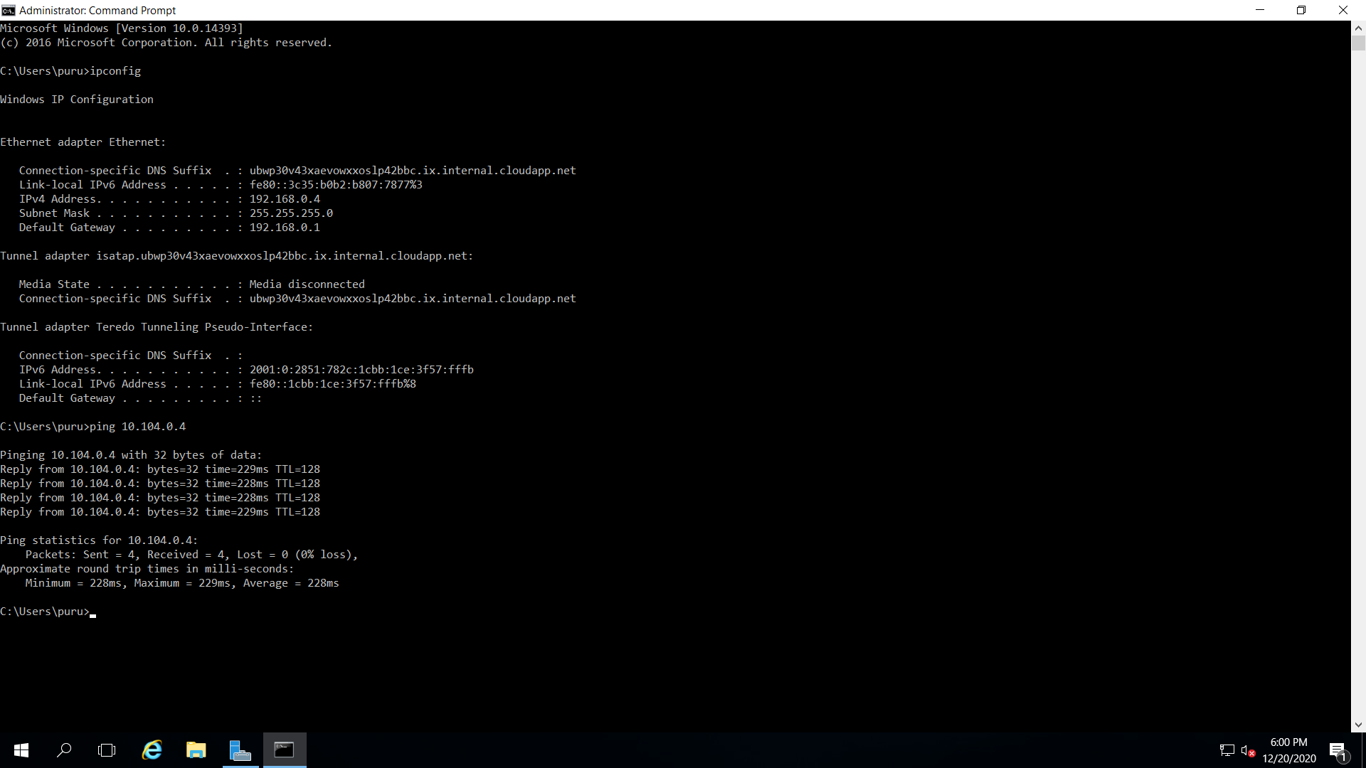

Both VMs are able to ping each other and Hence the project is completed successfully.